Topics Selected on HEALTH COMMUNICATION AND DOCUMENTATION
Knowledge area:
1. Principles of Communication
Need of effective communication skills
Types of communication
2. Counseling Techniques
Basic elements of counseling
Techniques of counseling
3. Suggested Reading

Practical Skills to be inculcated:
Core competencies/ Skills | Transactional strategy/ methods | Exercise
Interaction with peers including seniors, teachers | Informal meetings, experience sharing sessions, ‘make a friend per month’
Interaction with the families | Field visit/ house hold survey  A pair of students to be delegated 20 families in rural & urban field practicing area | Assess the health situation by adopting the life cycle approach/ index case approach,
Interaction with patients: | Hospital set up: OPD & In patients dept. | Observing the art of communication of senior doctors with patients, Explaining the advise of senior doctors, acting as a link communicator with the doctor & patient
Communication with the families of patients | Explaining patients’ situation to family, | Explaining the treatment to families,
How to conduct focus group discussion | FGD
How to conduct an interview |  | Interview the community leader to assess the health needs of the community
Social mobilization: |  | Organize health melas
IEC strategies
- Undertake individual counseling sessions
- Undertake group counseling
- Interpersonal counseling for sensitive issues
Resource mobilization from communities
Understand the consequences of mass- media |  | Analyze a message in any media ( TV, radio) related to health . Ex: advt. of Horlics, diabetes
Affective Domain:
The locus of learning for specific learning units in affective domain are difficult to be decided a priori. The group stops short of being prescriptive, while leaving this underscored area to the leadership in the Dept.

CONTENTS

SECTIONS | Topics
SECTION - A | INTER-PERSONAL SKILLS
SECTION - B | FOCUS GROUP DISCUSSION
SECTION - C | INTERVIEW
SECTION - D | SOCIAL MOBILIZATION:
SECTION - E | COUNSELING
SECTION - F | BEHAVIOUR CHANGE COMMUNICATION
ANNEXURE
Annexure- 1 | Communication game “Pass it on”
Annexure- 2 | Tips for making poster
Annexure- 3 | Guide for Conducting Community Leader Interviews

SECTION – A

INTER-PERSONAL SKILLS

INTERPERSONAL COMMUNICATION
Structure
- Objectives
  - Introduction
  - Listening Skills ------ A Checklist
  - Listening Skills --- Self Evaluation
  - Self Evaluation of Listening Skills
  - Rating Your Partner’s Listening Skills
  - Assessment of the Listener

Self – Assessment

1.0 Objectives
After undergoing this unit the students shall be able to:
- Describe the importance of Interpersonal Communication.
- Explain self- understanding and interpersonal behaviour through transactional analysis.
- List the skills of listening required for effective communication in the hospital setting.
- Demonstrate various listening skills with respect to various hospital situations.
- Describe barriers to active listening.
- Evaluate one’s listening skills

  - Introduction
Managers are not born. They are made. This effort involves a systematic process. Management of people is not a child’s play. Every manager cannot do it. It is an art. It needs to be mastered. Management of people can be either for good or for bad. General intelligence and knowledge are necessary but not sufficient conditions to deal with people and manage interpersonal relationships. Positive outcome in any interpersonal communication process depends on the repertoire of the skills possessed by the manager.” What” a manager communicates to the team is important but “how” he communicates contributes significantly towards effective work outcomes. Listening skills also have a crucial role to play. These skills focus on improving not only the task outcomes but also to improve the communication process in terms of enhancing the art of active listening. They include proper response options, responding to content, feelings, beliefs, values, perception checks, non-judgmental approach, suspending advice, responding to non- verbal behaviour and empathy.

  - Listening Skills ------ A Checklist
 |  | Yes | No
 | Focused upon the content (What? Who? Why? When? Where? How?)
 | Focused on Manner of Presentation
 | Focused on tone of voice
 | Focused on the affect
 | Suspended personal values and beliefs
 | Suspended judgement and premature solutions
 | Reflected and paraphrased
 | Used perception checks
 | Used I statements
 | Summarized

  - Assessment of the Listener

Active Listening – A Rating Scale

1. Use of Body Posture (E.G. Learning Forward) and Eye Contact To Show interest.
______________________________________________________________
1 2 3 4 5 6 7
Ineffective Highly effective

2. Use of encouraging words (e.g. uh huh, yeah or yes) and head nods.
______________________________________________________________
1 2 3 4 5 6 7
Ineffective Highly effective

3. Use of inviting, open – ended questions
______________________________________________________________
1 2 3 4 5 6 7
Ineffective Highly effective

4. Restatement of what is said to show real listening and understanding. .
______________________________________________________________
1 2 3 4 5 6 7
Ineffective Highly effective

5. Checking to clarify what was said.
______________________________________________________________
1 2 3 4 5 6 7
Ineffective Highly effective

6. Summing up at appro9priate points what was said.
______________________________________________________________
1 2 3 4 5 6 7
Ineffective Highly effective

Self – Assessment
My Skills as a Listener
Element | Never | Seldom | Occasionally | Frequently | Always
1. Do I listen for feelings, attitudes, perceptions, and values as well as for facts
2. Do I try to listen for what is not said?
3. Do I avoid interrupting the person who is speaking to me?
4. Do I actually pay attention to who is speaking as opposed to “faking” attention?
5. Do I refrain from “tuning people out” because I don’t like them disagree with them, find them dull, etc.
6. Do I work hard to avoid being distracted from what is said by the speaker’s style, mannerisms, clothing, voice quality, voice pace, etc.
7. Do I make certain that a person’s status has no bearing on how well I listen to him/her?
8. Do I avoid letting my expectations – hearing what I want to hear – determine or influence my listening behaviour?
9 Do I try to read the “monverbals” the speaker presents – inflections, gestures, mood, posture, eye contact, facial expression?
10. Do I work hard at overcoming distractions (sounds, noises, movement, outside scenes, etc.) that may interfere with good listening?
11. Do I tend to “stay with” speakers who may be hard to follow those who are slow in their speech or whose ideas are poorly organized or who tend to repeat themselves, etc.?
12. As a listener do I use nonverbal communication (eye contact, smiles, occasional head nods, etc.) to indicate that I wish to hear more?
13. Do I tend to restate or rephrase the other person’s statement when necessary so that he/she will know that I understood?
14. If I have not understood, do I candidly admit to this and ask for a restatement?
15. Do I avoid framing my response to what is being said while the other person is still speaking?
Let Us Sum Up
After doing a few exercises using rating scale and check list have been included with the purpose of self-assessment of listening skills so that the gaps can be identified for enhancement of active listening skills which have a crucial role to play in a sensitive situation like a hospital. Listening skills also have a crucial role to play on improving the communication process in terms of enhancing the art of active listening.

EXERCISES ON INTERACTION OF THE STUDENTS

Objective of the segment
- Enable students to find their lacunae and inauthentic thoughts peers including seniors, teachers
- Interaction with the families in the communities.
- Interaction with patients and families of the patients.

Exercise -1
Human Relation Skills— PEERS / colleagues
Consider your interaction with your colleagues / fellow students and answer the following:
AREA | YES | NO
Always help colleagues whenever they seek help in their task / projects

Don’t seek unfair advantage / rewards by unnecessary criticism of colleagues or by highlighting their weakness’

Do not feel jealous when colleagues are rewarded or appreciated for their performance

Do not feel threatened by colleagues

Do not go for unhealthy competition or leg pulling with your colleagues remain calm and positive even when your colleagues play games / tricks with you

- List the NO responses

- These areas you need to improve to enhance your human relation skills which are crucial for effective leadership and communicator.

Exercise 2:
List the people around you don’t like, you want to be in communication with some person.
Name of individual | What he/she do you does not like or they don’t like you | Is any cost you are paying to be not friend with him/ her | What was the last thing he had done that separate you and him apart | What are the ways you can do do to patch up if you forget the past

Approach to the person and frame your conversation like
- I am sorry for ……..
- It was my entire fault
- Cost I am paying is this…[cost may be in term of happiness, power, mental peace, economic loss ,etc]
- What can I do to make the things better?- most important part of the conversation.
Note: Even if you think that it was his/ her fault, just ignore that though for a minute and practice the above conversation.
If you got the answer “NO” don’t be afraid – it is just a word which is a negative response to the proposition you are giving to them. Just reframe your conversation and try again and wait for the people to show their good side.
Source:
Adapted from “last lecture” from late Dr Randy Paush
Activities taken from teachings of landmark education

Human Relation Skills- seniors and teachers

Exercise 3

Consider your own self when you are usually deal with your teacher and answer the following:
AREA | YES | NO
Do you know his background, habits, aspirations, likes, dislikes, work style, expertise, etc.
When you undertake an assignment you give your best to complete it successfully
Listen to him carefully with eye to eye contact. Read and understand his facial expressions and other body movements.
Respond to his queries after understanding them
Ask a question if things are not clear to you
Speak briefly, clearly and to the point
Gently point out, in case you do not agree with his remarks
Highlight his strengths in front of others
Give him all the information before a meeting
Do not intervene unless invited to speak in meeting
Let him take credit for your ideas
Highlight strengths of colleague rather than their weaknesses while talking to him
Solve your departmental problems yourself·
Maintain discipline and decorum

- List the NO responses

- These areas you need to improve to enhance your human relation skills which are crucial for effective leadership and communicator.

Source:
Exercises for the training on leadership by Dr Sood from NIHFW for senior hospital administrators
Concept taken from www.landmarkeducations.com

SECTION – B

FOCUS GROUP DISCUSSION

FOCUS GROUP DISCUSSION

OBJECTIVE OF THE TOPIC
- What is Focus Group Discussion
- Why we need and how to conduct it
      - Preparation
      - Piolation/how to carry
      - Report writing
      - Sociogram
- Demonstration
- Sociogram
- For whom FGD is more useful

Sample – FGD checklist
exercises

FOCUS GROUP DISCUSSION
Objectives
Identify the :
Purpose, uses, and limitation of FGD as a method of data collection in research, monitoring and evaluation.

WHAT IS FGD?
A FGD is a group discussion of 6-12 persons guided by a facilitator, during which group members talk freely and spontaneously about a certain topic

Characteristics:
- Group situation
- Limited member (6-12)
- Participants talk with each other
- Guided by facilitator +Recorder
- Members stimulated by the comments of others
- Make difference with purpose, process and people. (PPP)

Why we need FGD?
- Participatory (with community +people)
- Qualitative method
- Low cost
- Direct approach with civil society
- Comparative ideas can be developed
- Observation and non-verbal communication

USES OF FOCUS GROUP DISCUSSION
- Obtain in-depth information on concepts, perception, ideas of the group, therefore important in research and develop research hypothesis.
- Formulate appropriate questions for more structured, large scale surveys
- Supplement information on community knowledge, beliefs, attitude and behaviour already available but incomplete or unclear
- Develop appropriate messages for certain programme including national health programme
- Explore controversial / sensitive topics

HOW TO CONDUCT FGD
There are three steps of conducting a FGD
- Preparation
- Conducting the session
- Number and duration of sessions

- PREPARATION
The preparation needed to be done on different activities in FGD. The first step would be
- QUESTION PREPARATION
- Prepare 5 or 6 good and relevant question to be discussed.
- Questions should be open ended and neutral.
- Questions should follow a logical sequence: moving from general idea to specific one focusing on the aim of research.
- Avoid closed ended questions which ask why? The kind of question which ask how and what should be preferred.
- Pretesting can be done.

- RECRUITMENT OF PARTICIPANTS
- Ideal size is 6-12 participants.
- Same socio-economic group /similar background, homogeneous group would be preferred.
- If interested in different perspectives, arrange FGDs for different groups; e.g. users-non users, men-women, older women-young women.
- Each major category of man /women should be included.
- participants should be invited at least 1 or 2 days in advance, and the general purpose of the FGD should be explained

- PHYSICAL ARRANGEMENT
- Arrange chairs/seating arrangement in circle
- Area/place will be quite adequately, lighted, no disturbance
- Try to hold FGD in a neutral setting – encourage for free and frank expression, views, and ideas.

- PARTICIPANTS INCENTIVES : food and beverages
- PREPARATION OF A DISCUSSION GUIDE
- Written list of topics
- Series of open-ended questions
- Blackboard, pen discussion aid

- CONDUCTING THE SESSION
One member of the team (research) should act as
- ‘Facilitator’ to stimulate + support
- ‘Recorder’ to unbiased systematic recording

FUNCTIONS OF THE FACILITATOR
- Introduce the session – purpose of FGD, kind of information needed
- Encourage discussion – be enthusiastic, humorous, encouraging
- Encourage involvement – avoid a Q. A. Session, importance of each participants
- Build rapport–observed non-verbal communication, body language, tone of voice etc.
- Avoid being placed in the role of expert – you are not suppose to teach/educate counselling them
- Control the rhythm of the meeting – control the time, topic, discussion
- Summarise, check for agreement and thank the participants – any additional comments

FUNCTION OF THE RECORDER
Should cover content + emotional reaction
Item to be recorded
- Date, time, and place
- Names & characteristics of participants, group dynamics (level of participants, dominant participants, interested participants)
- Opinion of participants – own words, key statements, vocabulary used by them
- Help in resolve conflict situation if any
- Support to maintain friendly and informal atmosphere

- NUMBER AND DURATION OF SESSIONS
- At least 2 sessions for separate group
- 75 min. each FGD
- Preparation of discussion guides (15 min.)
- Discussion (50 min.)

ANALYSIS OF RESULTS
- After each FGD, both ‘Facilitator’ + ‘Recorder’ review and analyse
- Full report + comment on unclear aspects and controversial topics
- Compare answer of different sub-group, any further suggestions

REPORT WRITING
- Decide to whom you are writing the report
- List of the topics guided by the objectives of FGD
- Composition of Groups of Participants (group dynamics)

TO WHOM FGD IS MORE USEFUL
- Developmental professionals
- Researchers
- Policy makers/decision makers
- Programme Managers
- Social reformers/mobilizes
- Programme implementers
- Counselors and grassroot workers

SOCIOGRAM
A Sociogram is a graphic representation of social links that a person has. A Sociogram can be drawn on the basis of many different criteria: Social relations, channels of influence, lines of communication etc
Characteristics of Sociogram
- Social relations of individual in a group
- Understand the IPC within the group
- Level of awareness on specific issues
- To know the group dynamics
- Group work method (action research)
- Ways and means to resolve the conflict

EXAMPLE - 1
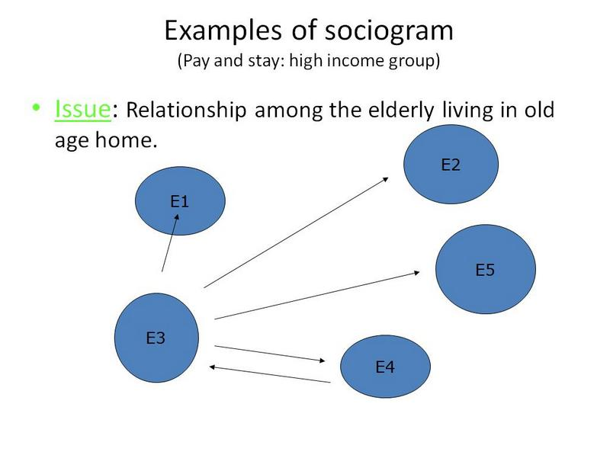

Analysis:
- E3 is social, having leadership qualities
- E1 bedridden no contact with others
- E2 only talks and contact with E3
- E5 only talks and contact with E3
- E4 mutual understanding with E3

Conclusion:

Loneliness within this group can be taken care of, if the groups have a level of interaction among themselves; where they can share: anxieties, problems or even solutions.
- E3 is more dynamic, can play a role as a leader
- Group activities were planed: lunch, TV etc.

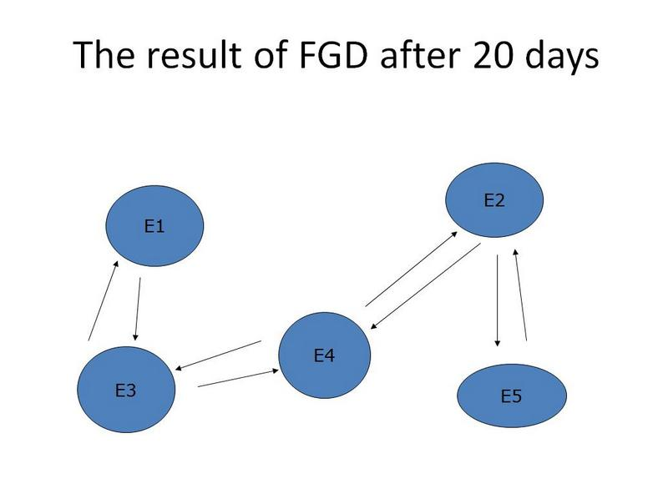

Progress in relationship

- Small initiative brought a change in their loneliness as E2, E4 and E5 started communicating/contact with each other
- E3 became the Catalyst (Sutradhar)
- More work is possible to improve the relationship to avoid loneliness among them.

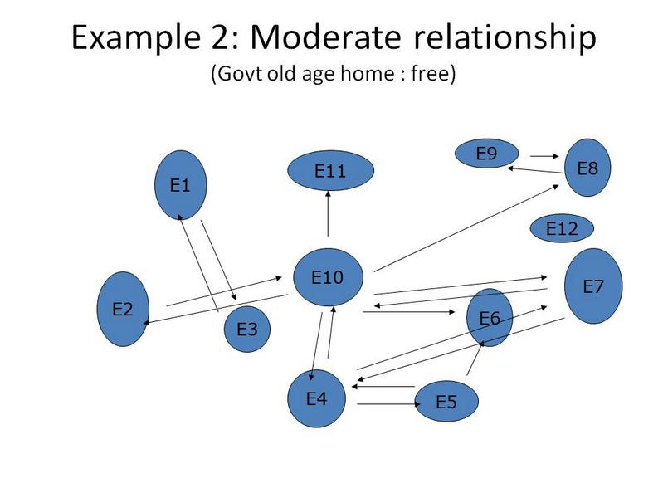

Analysis:
- E10 has a leadership quality
- E12 is a loner
- E2, E5, E1 and E3 has less interaction with others than E10
- Many behavioral problems identified, relationship is poor and less interaction among them etc.

Conclusion:
- Suggestions:
- Effective planning for improvement in their interaction is needed
- Participation in group activity is required
- Possibility to utilize their leisure time in productive work etc.

Analysis:

- E10 has a leadership quality
- E12 is a loner
- E2, E5, E1 and E3 has less interaction with others than E10
- Many behavioural problems identified, relationship is poor and less interaction among them etc.

Conclusion:
- Suggestions:
- Effective planning for improvement in their interaction is needed
- Participation in group activity is required
- Possibility to utilize their leisure time in productive work etc.

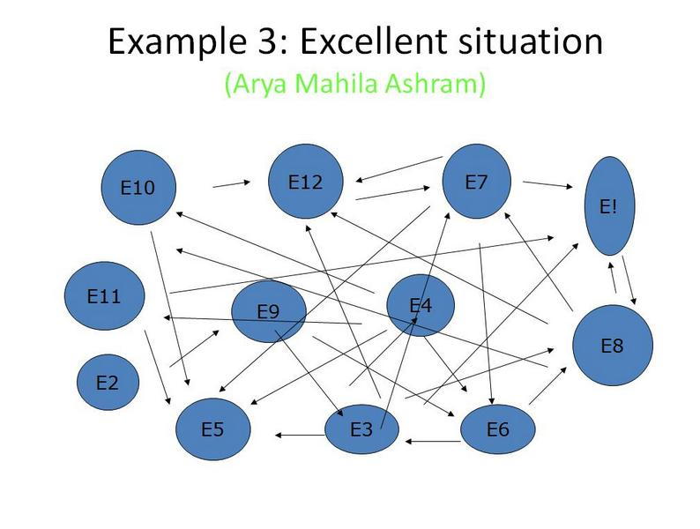

Analysis:
- The individual has less chances to be lonely
- The group is well organized and concerned with each other through multiple activities.
- All the individuals are involved in one or the other committee related to the functioning of old age home.
- Continuous communication and interaction exists among them
- Clear and concrete relations

Conclusion:
- Out of above 3 examples, the last one can be analysed as role model in which every individual has a social relationship in a group as we expect.
- social environment may be a basic reason for their group behavior
- Some of the characteristics of this group can be replicated in other old age home, if possible.

Source: Written material on PLA techniques by Professor Y.L. Tekhre ,Department of Social Sciences,NIHFW, New Delhi-67

Example of Checklist of FGD done by NIHFW on review the health care delivery services

A STUDY TO REVIEW THE HEALTH CARE DELIVERY SERVICES PROVIDED BY PUNJAB HEALTH SYSTEMS CORPORATION (PHSC), PUNJAB

FOCUS GROUP DISCUSSION
Male/Female

District | Date

Commencing Time
Village

Concluding Time

Sat Sri Akal. I am ……………………….. from National Institute of Health and Family Welfare, New Delhi. I am here with my colleagues to do a survey of the healthcare facilities in this area. Our team would like to ask some questions pertaining to health services provided by the health care facilities. Your participation in the survey would contribute to improving health services. You are an important stakeholder in this survey and therefore we would appreciate if you could spare some of your valuable time. Your responses will be treated as confidential.

Instructions:- The person who asks the questions /facilitates the discussion is the facilitator, he will sit in the middle of the semicircle. Another person who records the proceeding is the moderator. Tape recorder will be in the middle of semicircle. Ideally written consent should be taken before starting the FGD. Moderator has to take written/oral consent from the participants, draw sociogram and pass the chit to facilitator regarding someone’s nonparticipation, if the discussion is deviating from the subject. His duty is also to tackle the outsider if he is creating trouble. In the end, facilitator will summarize shortly and thank participants with a cup of tea.

- Accessibility to health care facility
  - Which health care facility do you avail? Govt./Private
  - If not going to Govt. hospital, reasons for non-utilization of Govt. health care services.
  - Distance from home and connectivity through road.
  - Transport facilities and cost of travel to health facility.
  - Did you have to pay for availing the services

- Availability of Facilities in the hospital
  - Waiting time in OPD .
  - Do you think that timings of the OPD are convenient to you?
  - Availability of Doctor/ Nurses/ Other staff
  - Availability of Medicine
  - Availability of Lab. & Radiological Investigation
- Behavior of Health care providers towards patient
a) Behavior of Doctor
b) Behavior of Nurse
c) Behavior of other staff

- Outreach Services offered by Govt. Facility
  - Home visits by ANM/ASHA for
  - Health education
  - Immunization
  - Family Planning Services
  - ANC services (TT, distribution of IFA)
  - Camps/Special Checkups

- Coverage
  - Coverage by Govt. Health Care facility (Adequate Coverage or not)
  - Do you think the Govt. Health Facility is fully equipped?
  - Are you satisfied with the services provided by Govt. Health Facility?

6. Please give suggestions for improvement in Health care services

Exercise
- Review the video tapes available in your PSM department. Note the position of recorder and facilitator. Make Sociogram of your own. Note the key points.
- Plan and arrange a FGD starting from choosing the topic , invitation of members, setting the venue, making the checklist, appointing recorder and facilitator . for making checklist take the help of above given PUNJAB health systems corporation (PHSC).

Exercise & Activity

Form the participants in to four groups. Each group to have a minimum of four to five participants. Give the two sets of data given below and ask the participants to identify the reasons for the status of the issue taken up. When they identify the reasons, it will be sued for developing FGD questions.

- Prepare the FGD Guide for the followings.

You have conducted Base line survey, you have found following responses and you want to enlarge your understanding on the issues emerging out of the following data.

The total responses are 200. Which method you / your husband is currently using to
avoid or delay pregnancy?

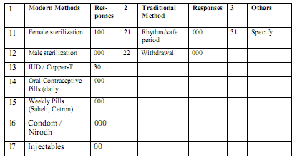

2) Prepare the FGD Guide for the followings.
You have conducted Base line survey, you have found following responses and you want to enlarge your understanding on the issues emerging out of the following data.

The total responses are 200

What is the main reason for currently not using any method of family planning?

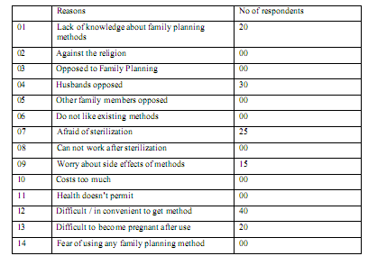

3 ) Prepare the FGD Guide for the followings.
You have conducted Base line survey, you have found following responses and you want to enlarge your understanding on the issues emerging out of the following data.

The total responses are 200, there were 102 deliveries in last 24 months.

Where did you go for check-up ?
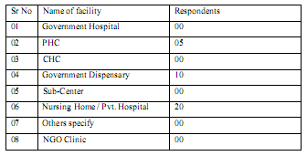

For the facilitator: Ask the participant to make presentation group wise.

When one group makes the presentation, ask the other groups to critique the same.

See the logic of the analysis and the questions developed.

Help the participants to choose questions that are relevant and those can help them to probe further in the FGD with a focus.

The questions should be open ended not leading and should not be judgmental.

This exercise is important to do because here the participants gain skills in understanding the collected data. The data given here is not real.

However, on the second day of the workshop, they will have opportunity to collect real data and fill the BLS format. On completion of the BLS work, the participants will analyze the collected data and identify areas that require further probing, or more clarity or require an understanding of the perspectives and practices prevailing in the community.

Based on the identification of the issues, the participants will then sharpen the FGD questions and decide on the methodology to be adopted for the FGD-will be a question, or a drawing inventing response etc.

Source:
- Module on data collection for identifying RCH status in the community
- Ppt on focus group discussion by Prof. Deoki Nandan [Director NIHFW, New Delhi] and dr Y L Tekhre.[ Reader , Dept of Social Sciences]
- Qualitative research method by Chandra kant laharia
- Review the health care delivery services provided by punjab health systems corporation (PHSC), PUNJAB by NIHFW report, 2008

SECTION – C

INTERVIEW TECHNIQUES

INTERVIEW TECHNIQUES
Objectives of this segment
- It enables the student the importance of different stages of interview and practice this technique in different conditions.
- Interview on sensitive topics
- Interview of community leaders, households

How to Conduct an Interview
Interviews have four stages:
- Arrangements and introduction phase
- General sharing of information:
- The actual interview and
- The reconstruction.
STAGE ONE: BREAKING THE ICE OR ESTABLISHING RAPPORT: THE FIRST IMPRESSION AND INITIAL SOCIAL EXCHANGES.
Arrangements and introduction phase
- Once you have decided to interview someone, call in advance to make an appointment.
- Identify yourself by your name and the purpose of interview.
- If you feel the need to do so or are asked to describe what the problem / situation is about, be brief and general.
- The shape of the problem / situation might change as you continue your reporting.
- If you are interviewing several persons in connection with the problem / situation, interview the principal person last, because you will be better prepared based on what you learn from the earlier interviews.
Breaking the Ice
This is the time to shake hands, say hello, and get acquainted. But its also much more. First impressions will be developing so be aware of your:
- Posture
- Eye Contact
- Energy Level

STAGE TWO: GENERAL SHARING OF INFORMATION:
The interviewers review of the available position and the tell us a little bit about yourself question. This is a request for your opening statement
PREPARATION phase
- Do as much research as possible in advance on the person and/or topic you are working on.
- Sources might include the library, public records, the internet and people you know who can provide background information.
- Prepare your questions in advance in writing and bring them to the interview.
- Refer to them but don't show them to the interviewee, because it creates too formal an atmosphere.
- Ask other questions as they might arise, based on what the interviewee says or something new that might come to you on the spur of the moment.
- Bring two pencils (or pens) and paper.
- A stenographer's notebook is usually easier to handle than a large pad but use whatever is comfortable.
- Bring a tape recorder if you can but be sure to get the permission to use it from the person you are interviewing
- You also should take notes, because it will help in the reconstruction phase, and, yes, tape recorders fail occasionally.
STAGE THREE: SHARPENING THE FOCUS:
BEHAVIOUR-BASED OR GENERAL INTERVIEWING QUESTIONS
THE INTERVIEW phase
- It is inadvisable to launch right into the interview unless you are only being given a few minutes.
- Some casual conversation to start with will relax both of you.
- Questions should be as short as possible.
- Give the respondent time to answer.
- Be a good listener.
- If he or she prattles on [meaningless chatter;], it is appropriate to move on as politely as you can.You might say something such as: "Fine, but let me ask you this".
- Try to draw out specifics: How long, how many, when, etc.?
- Absorb the atmospherics of the locale where the interview takes place, with particular attention to what might be a reflection of the interviewee's personality and interests, such as photos of children or bowling trophies or a paper-littered desk or a clean one, etc.
- Note characteristics of the interviewee that might be worth mentioning in your story, such as pacing, looking out the window to think, hand gestures and the like.
- Invite the person to call you if she/he thinks of anything pertinent after the interview.
- It often happens, so be sure to provide your name, email address and phone number on a card or piece of paper before you leave.
- If that person has a secretary/ family member, be sure to get that person's name and telephone number, too, in case there is some detail that needs follow-ups and, again, leave information as to how you may be contacted.
- If a photo is needed and is not taken during the interview, be sure to make arrangements then to have one taken at a later time.

STAGE FOUR: CLOSURE: OPPORTUNITY TO ASK QUESTIONS AND MAKE A CLOSING STATEMENT.
RECONSTRUCTION phase
- As soon as it's practical after the interview, find a quiet place to review your handwritten notes.
- In your haste while taking notes, you may have written abbreviations for words that won't mean anything to you a day or two later.Or some of your scribbling [Careless hurried writing] may need deciphering [read or interpret], and, again, it is more likely you'll be better able to understand the scribbles soon after the interview.
- Underline or put stars alongside quotes that seemed most compelling. One star for a good quote, two stars for a very good one, etc.It will speed the process when you get to the writing stage.
- One other thing to look for in your notes:the quote you wrote down might not make a lot of sense, unless you remember what specific question it was responding to.
- In short, fill in whatever gaps exist in your notes that will help you better understand them when writing.
Source: http://stringers.media.mit.edu/interview.htm

EXERCISES
Exercise 1: Visit to the ICTC centre in your hospital and see the check list used by the STD counsellors. See the tapes of interview available. Witness a interview done by the counsellors.
Hint: take help of the given check list.
STD Interview Checklist
1. Basic pointers
• Ensure privacy
• Maintain confidentiality
• Never make assumptions
• Maintain a non judgmental attitude
• Acknowledge personal or patient discomfort
• Maintain a relaxed body language
• Use words and terms that the patient understands

2. General history
• Contact of a STD
• Past medical history
• Past STD history
• Medications
• Allergies
• Contraception
• Last menstrual period
• Vaccination history
• Recreational drug use

3. Symptoms and signs
• Anogenital discharge
• Dysuria
• Dyspareunia
• Pelvic pain
• Genital/perianal ulcers or lumps
• Rashes
• Itching

4. Sexual behaviours/risk markers
- Regular/casual sexual partner(s)
- Last sexual contact
- Gender of partner(s)
- Any history of male to male sexual contact
- Type of intercourse – oral, vaginal, anal
- Use of condoms
- overseas, interstate sexual contact
- Use of beats, saunas, internet
- injecting drug use
- Tattoos
- Blood product exposure (pre 1985 for HIV, pre 1990 for Hepatitis C risk)
- Needle stick injury

Source: http://www.stdservices.on.net/management/checklists/cl_interview.htm
http://www.elevateyourcareer.com/p165.html

4. Sexual behaviours/risk markers
• Regular/casual sexual partner(s)
• Last sexual contact
• Gender of partner(s)
• Any history of male to male sexual contact
• Type of intercourse – oral, vaginal, anal
• Use of condoms
• overseas, interstate sexual contact
• Use of beats, saunas, internet
• injecting drug use
• Tattoos
• Blood product exposure (pre 1985 for HIV, pre 1990 for Hepatitis C risk)
• Needle stick injury

Source: http://www.stdservices.on.net/management/checklists/cl_interview.htm
http://www.elevateyourcareer.com/p165.html

Exercise 2: plan a visit to the local community nearest to your college and interview the local people regarding their needs (problems in water and sanitation, utilization of health services by the local peoples, etc.) use your PSM family folder. Special emphasis needed to be done in stages of interview.

Exercise 3: practice a interview in supervision of your facilitator on sensitive topics like, contraceptive practices in the community , non acceptance of NSV by men, awareness regarding contraceptive measure especially among young adults. Conduct a FGD regarding these topics.

Exercise 4: Conduct a interview regarding the health seeking behavior of the family
Hint:

Checklist for interview for HEALTH SEEKING BEHAVIOR

- What is done usually to treat minor ailments including home remedies (specify) – in cough/ cold. Fever, diarrhoea, cut burns boils, others
- Belief in self medication/Faith healing
- First line of contact in acute / chronic illness
- Name of the Health facility the family visits
- Whether satisfied or not with the services (reasons tor dissatisfaction, if any)
- Utilization ofHea1th service’s -Antenatal care, Delivery of baby Immunization of child/woman ,Pulse polio rounds
- Regularity of taking medications /follow-up visits – for child & adults

Family diagnosis
- Demographic factors-risk/ vulnerable groups
- Social factors/ social cultural factors
- Environmental-physical and biological factors
- Psychological and behavioral actors
- Dietary factors and patterns
Any illness in the family
Clinic-social diagnosis+ medical condition + a summary of social conditions

Note: also, take questions from the previous checklists.

Exercise 6: Practice an interview in supervision of your facilitator on physical and biological environment of the household.

Checklist for PHYSICAL AND BIOLOGICAL ENVIRONMENT household interview
- PHYSICAL ENVIROMENT
Housing
- Type of house
- Type of construction
- Overcrowding
- Lighting
- Ventilation
Kitchen
- Location
- Lighting
- Floor
- Water supply
- Cleanliness
- Fuel used
- Smoke outlet
- Storage of cooked food
Water supply and storage
- Source of drinking water
- Type of supply
- Storage
- Method of drawing water from storage container
Refuse disposal
- Method of refuse disposal
- Storage /refuse inside house
- Frequency of disposal
Toilet and bathroom facilities
- Location of Toilet
- If inside the house, type of latrine
- If community toilets approximate number of users/ tpilets
- Toilet cleanliness
- Bathroom
- If in the house, water supply
- Drainage of sullage
- Cleanness of bathroom
- BIOLOGICAL ENVIROMENT
- Adult mosquitoes in house
- Mosquito breeding sites
- Other insects
- If present, rodents
- Any pet. Poultry/ domestic animal
- PERIDOMESTIC ENVIRONMENT
Refusal disposal:
- Storage of refuse in the community
- Distance of community bin/ refuse storage area from the house
- Removal of refuse from that Bin Area
- Frequency of removal of refuse
Breeding place of vectors and arthropod:
- Mosquitoes breeding sites
- If actual breeding sites present its distance from the house
- House fly breeding sites
- Poultry/ domestic animal

Exercise 7: Practice an interview in supervision of your facilitator on SOCIO-CUL TURAL AND PSYCHOLOGICAL ENVIRONMENT of the household.
Checklist for interview on SOCIO-CUL TURAL AND PSYCHOLOGICAL ENVIRONMENT
Social factors
- Social group- religion caste
- Type of family
- Literacy status
- Any school dropout –reason
- Occupation of family members
- Income of family
- Social class
- No. of unemployed. Dependents, retired persons, married, unmarried
- Relationship within family-couple, parent and children, siblings
- Relationship with community- as family. as individuals
- Tradition and customs regarding marriage- desired age, average expenditure, dowry, consanguineous? Gauna, family size etc.
- Any illness/ handicap in family
- Recreational facilities for children
- Means of leisure time for children
- Any substance abuse
- Decision makers for in family issues
- Economic, social, psychological constraint of any of the above factors in the family- summarize and make social diagnosis
Cultural factors
- Practices for marriage
- Dietary pattern of family
- Practices during pregnancy and child birth
- Practices during Breast feeding/ weaning
- Practices during Childhood illness diarrhea/ chest infections and others
- Important festivals the family celebrates.
Psychological environment
- Any reason for psychological stress in the family
- Any member on therapy of mental illness
- Any family member who is mentally retarded/ extent of etardation
- Any Marital maladjustment/ separations in the family
- Any Sibling rivalry /reason
- Any Conflict in the family / with neighborhood
- S Any tress experience in the work place
- Any crisis family faced in recent past. How they manage it?
Take opinion of the neighborhood regarding the conduct of the family
Summarize the cultural and psychological factors present in context with health and disease of the family.
Family dietary history-Food items consume per day

Exercise 8: Divide the group into five and plan an interview with the community leader, local influencers, and panchayat members. You can use the format mentioned below. Try to generate other relevant questions.

Hint:
SAMPLE INTERVIEW GUIDE - COMMUNITY LEADER
Family Care International – Skilled Care Initiative – Qualitative Research
Individual or Group In-Depth Interview Guide:
COMMUNITY LEADER

Interview Schedule
Interviewer Comments:
Interviewer code_________________
Date_________________
District_________________Location_________________
Venue_________________
Time: from_________________to_________________
IN-DEPTH INTERVIEW WITH INDIVIDUAL OR GROUPS OF COMMUNITY LEADERS
Respondent Code:
Address/Location:

Name(s) and role(s) of respondent(s) in community:

SOCIAL NETWORKS AND COMMUNICATION CHANNELS
NOTES FOR THE INTERVIEWER
Key ideas to explore:
• What types of social networks and gatherings exist in the community?
• What sources of information do women and their families rely on?

1. What types of community-level organizations, groups or social networks exist in this community?
Probe about community development associations, religious groups, sporting clubs, etc.
2. What types of groups are women involved with?
How frequently do these groups meet? What are the socio-economic characteristics of the women who are participate in these groups? What types of women do not get involved?
3. What types of groups are men involved with?
How frequently do these groups meet? What are the socio-economic characteristics of the men who participate in these groups? What types of men do not get involved?
4. What other periodic gatherings take place in the community?
Markets, sporting events, etc.? How frequently do these gatherings or meetings take place?
5. Where do most men in this community get news and information?
Probe about mass media outlets (radio, print media, and television) and social networks (e.g.
religious groups, sporting clubs, etc.
6. Where do most women in this community get news and information?
Probe about mass media outlets (radio, print media, television) and social networks (e.g. women’s groups, religious groups, etc.)
7. What do you think are the most effective channels for communicating information about health?
Probe for suggestions for reaching men, women

UTILIZATION OF SERVICES
NOTES FOR THE INTERVIEWER
Key ideas to explore:
• What are community leaders’ perspectives on women’s utilization of maternal health services?
• Do communities track pregnancies and record births?

8. What factors do you think affect women’s use of health services during childbirth?
Do concerns about quality of care/treatment by health providers prevent use of services? Do costs or travel distances limit use of services? Lack of knowledge about when to seek care?
9. In your view, what would be the most effective way to increase use of
health facilities during childbirth?
Probe for suggestions for addressing women themselves, as well as other important household decision-makers .
10. Are births that take place in the community registered anywhere?
Probe to ascertain whether births that take place at home are officially registered and if so, with whom
11. Do community leaders generally know which women are currently
pregnant/ expecting a child?
Probe to ascertain who, if anyone, would know this information and how and when the information would be shared by women or their families
12. If no systems for monitoring pregnancies or registering births in the community exist, do you have any suggestions for how such a system could be established?
Probe for suggestions about who in the community would be best positioned to keep track of this information and how

OBSTETRIC EMERGENCIES
NOTES FOR THE INTERVIEWER
Key ideas to explore:
• What level of understanding does community leaders have obstetric complications?
• What are community leaders’ perspectives on the “three delays”?

13. Around here, what types of complications do women have in late pregnancy, labour, delivery and the period immediately after birth?
For each problem mentioned, ask:
How serious is that problem? What can happen to a woman who has this type of problem?
14. Can you think of any occasion when a woman experienced a complication
during pregnancy, childbirth or after delivery?
Probe for information on what kind of complication(s) occurred; what steps were taken and by whom, and what was the outcome of the case(s)
15. In the past, when women have experienced serious complications during
pregnancy, delivery or after delivery, what has the community done?
Probe for information about whether the community has assisted in transporting the woman to a health facility, contributing funds, etc.
16. Are women with complications able to quickly access the care they need?
Why or why not?
Probe for details about difficulties in accessing appropriate care  e.g. difficulty finding transport, funds, etc.
17. When women with complications reach a health facility, do they get the
care they need?
Probe for perspectives on the quality and availability of care

COMMUNITY MOBILIZATION AND SUPPORT SYSTEMS

NOTES FOR THE INTERVIEWER

Key ideas to explore:

• What types of mobilization activities has the community undertaken to improve the quality of and access to maternal health services?
• What types of resources or support systems that could be used to help women access health facilities during delivery exist in the community?
• What kind of contributions could the community afford to make to improve available health services?

18. Can you describe any mobilization activities that this community has undertaken to improve the quality of and access to maternal health services?
Probe for details about the types of projects undertaken and the outcomes of these efforts
19. Can you describe existing community resources or support systems that could be used to help women access health facilities during delivery?
Probe for details about emergency loan funds, vehicles, etc.
20. What kind of contributions do you think this community can afford to make to improve available health services?
Probe for details financial contributions, digging a well, building an additional room or storage area for a facility, etc.
Say: Thank you for answering all our questions about your community. Maybe you have thought of something that we have left out. Is there anything else that you’d like to tell me/ us about your experience?

THANK YOU VERY MUCH FOR TAKING THE TIME TO TALK TO ME/US.

Source: Family Care International – Skilled Care Initiative – Qualitative Research, www.familycareintl.org

SECTION – D

Social Mobilization

Social Mobilization
Objective: student will understand the importance of Social Mobilization in health communication and also sensitize to the field and encounter problems occur in social interactions by mean of means of communication.

Definition:
Social mobilization involves planned actions and processes to reach, influence, and involve all relevant stakeholders from the national to the community level in order to create an enabling environment and to affect positive behaviour and social change in the context of best practices.

INTERRELATIONSHIP OF COMMUNITY MOBILIZATION, ADVOCACY, BEHAVIOR CHANGE COMMUNICATION, AND SOCIAL MARKETING

Component | Reach Whom | Objective | Link to Social Mobilization
Community Mobilizing | People who have a geographic/  demographic grouping, such as  women and men in their  reproductive years, youth, people  at risk for STDs, AIDS.  Example: A campaign to delay  early marriage or early birth might address parents, young husbands, mothers-in-law. | To get people involved in making a change in behavior , custom, resource allocation, or policy within their group.  Example: In the case of  reproductive health, community mobilization might increase dialogue about family planning. | Spark for social mobilization may come from outside the community, but it needs community ownership, support, and engagement to achieve  desired behavior change.  Example: A national campaign promoting better-prepared childbirth will change behavior in a lasting way only if the community initiates, understands, supports, and is actively Engaged.
Behavior Change  Communication | Usually defined in terms of age,  sex, locality, etc.  Example: Young men living in  urban areas, married women  with more than 4 children | To raise awareness, increase knowledge, increase intention to practice a certain behavior, change behavior, create advocates for a certain behavior . | Behavior change communication is important for broad dissemination of messages designed for a particular audience.  Example: Radio/television dramas or spots, face-to-face communication with clinic, workers community events.
Advocacy | Targets policy and lawmakers | To change policies, laws, programs, resource allocation. | Policy, legal, programmatic, and resource allocation issues are part of social mobilization objectives, thus important.  Example: Social mobilization for reproductive health for youth may target lawmakers and policymakers to change legal and marital requirements for accessing contraception.
Social Marketing | Tries to reach the person who  makes the decision to buy, the  person who buys, and the person who consumes a product with social value. These may not be the same person. | To raise demand and increase distribution for products and services with social value through increased numbers of retail outlets, increased awareness of where products are available, and increased numbers of people who purchase such products or services. | Social Marketing can link with social mobilization when there is a product or service that will help bring about the behavior change that is sought.  Example: Increasing availability of condoms and pills through retail outlets.
Source: Social mobilization for reproductive health from THE CENTRE FOR DEVELOPMENT AND POPULATION ACTIVITIES
CHARACTERISTICS OF, EXAMPLES OF, AND REASONS FOR DOING SOCIAL MOBILIZATION
Characteristics of  social mobilization | Examples | Reasons for doing  social mobilization
1. Promotes an issue of  broad concern | • Mobilization for women’s right to vote  in the U.S. and other countries  • Mobilization to save the rain forests  - 15th October in global hand washing day celebrated in majority of schools of India. | • To increase people’s  awareness and knowledge  • To change behavior and enable people to act on an important issue  • To help people understand their rights  • To help people demand satisfaction of their needs  • To bring together the broadest resources possible to an important issue  • To bridge the gap between people with and without power
2. Can build broad concern for an  issue that was not previously recognized as important | • Boycott of Nestlé’s products raised awareness  about the importance of breastfeeding  • Condom Day in Nepal empowered people to  talk and act about a sensitive topic
3. Involves more than one organization or community | • Mobilization against teenage smoking has  involved sports heroes, movie stars, government public health departments,  schools, community groups.
4. Uses a variety of approaches at the same time | Social mobilization for HIV prevention can  use humor through drama, fact through mass  media, and persuasion through peer  networking.
5. Once an idea is grasped, can move quickly and spread widely | • Indian women who mobilized against liquor  consumption got alcohol banned in whole  communities.
6. Demands risk-taking | • Pro-democracy movement in China
7. Full effects sometimes take years | Awareness and action on the AIDS epidemic
8. Is empowering in terms of the process and the outcome | • Nigerian women in the 100 women’s groups  who organized to learn more about their right  to vote took on more difficult issues like  domestic violence.  • Senegalese women moved from a village  literacy class to an advocacy effort that  changed the law on female genital cutting.

ACTIVITY THROUGH CASE STUDY
- Divide participants into four groups
- Distribute the case study to each of the participants
- Ask them to read the case and discuss the allotted question, write the answer on a chart paper Each group along with the allotted question will also answer part (i) of question 4. However group 4 will answer both parts (i) and (ii) of the question.
- Each group presents
- Summarization of key points

Case study:
JANAKA’S STORY
Janaka is a field officer and has been working in her project area for 11 months now. After the inauguration of the project, she and her other two colleagues developed a work plan for mobilising women into groups in the field areas allotted to them. Each was allotted a population of 3000. Average number of households was 300 and family size was 5-7 persons per house. The households were spread over 20 villages. There were no anganwadi centres, ANM never visited these villages and there was no primary school in villages. Community mobilization and service delivery were the two strategies of the project.
Janaka started work in village Lakhanpur. With the help of the local children she located the house of the village pradhan, explained her purpose for the visit and sought his cooperation for identifying a suitable space for the women’s meetings. He offered her an empty shed in the village where she could sit and talk to the women. The following day, Janaka informed the women about the meeting and venue. Initially, the response from the women was poor, but this did not deter her from meeting them. The women assisted her in cleaning the shed, made alpana on the walls and together put up some pictures of mother and child. In consultation with the women, a date and time for the inauguration of the centre was fixed.
Alpana- local art work that is drawn on ﬂoor or walls of the houses in villages as decoration and good luck charms.

The Pradhan was invited to light the lamp of their centre. The entire village had gathered and all were happy. Simultaneously, Janaka began similar activities in the cluster of villages surrounding Lakhanpur.
From month two onwards, Janaka began her fortnightly group meetings. During the first 2-3 meetings the group was large; there were young girls and women of all ages including the older ones. Janaka spoke to them about the project and her organization. She told them that during the meetings she would give them important information about their health and for their children. Their organization was working with the Government doctors to organize medical aid for their village and she hoped this would be possible in a couple of months. During the course of the discussions, Janaka also gained an insight into the lives of the women. Only a few of the younger group had studied up to class five. Most women belonged to a very poor socio-economic class and worked aswage labour in the larger fields or nearby brick kilns. They did all the household chores including collection of drinking water, cooking, caring for their livestock and looking after their children. Their men worked as wage labourers. Several misconceptions existed among the community, including that children are God’s gift and it was not in their ands to limit their families. Pregnant women should eat less so that they can have small babies and delivery is easy. Delivery was usually in a cow shed or dark corner of the house. An older woman from the family or the local dai was called to assist during the delivery. Many were dai was called to assist during the delivery. Many were daiignorant about tetanus toxoid injections. There was also the belief that the death of newborns was either due to the evil eye or God’s punishment to the family and the village.
During the course of these discussions she also felt that many were quiet and shy, while only a few women gave a positive response. Some even told her she was wasting her time. Even after working for four months in Lakhanpur , Janaka was unable to see any change in the attitude of the women. They came because she came, never met even once when she was not there, and only some showed a real interest.
She shared her fears and apprehensions with the two other field officers and supervisor. They too had similar stories to tell. It was decided that the field officers should find out a little more about their common problems and difficulties and see if addressing key concerns could make a beginning. Janaka’s supervisor came with her to Lakhanpur during her next fortnightly visit. The women were happy to see the supervisor, but told her that they needed work. They liked the idea of meeting in a group but only discussing health and talking of problems in health was not enough. Collecting potable water was a time consuming process and the women had to walk long distances to collect water for drinking and cooking. There was a great shortage in these parts and in another two months the wells would dry up. This was causing considerable anxiety to the women.

The project team jointly decided that they should explore the possibility of helping the village women overcome this critical bottleneck. Janaka took the pradhan and a few women to the BDO’s office to discuss the water problem existing in the village. After discussing at the block headquarters, they were able to convince the authorities to allocate 2 hand pumps from the Government scheme for providing potable water to water-scarce villages. The BDO also explained that it was necessary to train local villagers in maintenance of the handpumps. Over the next two months, in collaboration with the water board, two women and one man from each of the villages were trained in hand pump boring, maintenance and chlorination of the water. They were given the necessary equipment. Initially, the work was started only in the identified village with women groups, but over the last 11 months 50% of villages in the project area were covered.
The pradhans and women were very happy that the project staff had listened to their problem. Janaka found more active participation in the fortnightly meetings. Women started sharing health problems and more importantly seeking solutions for their common problems affecting a large number of them. They were able to suggest timings for the visits of medical teams to their village. Janaka also got an insight into the yearly work cycle of the women folk including their local festivals. She was also able to identify persons of influence in the village community. All this helped in maximizing satisfaction levels from the visits of medical teams from block and district headquarter. During the course of the next six months Janaka was able to successfully organize and conduct an antenatal camp.

Questions
Group –1 | Why did the project team not get a breakthrough in the initial four months?
Group-2 | What were the turnings points that to anchoring the health interventions?
Group-3 | What insights did Janaka get about the village women?
Group-4 | - Identify the key steps that lead to successful delivery of Health Services  - As an health officer in charge , how will you ensure the successful service you ensure the successful service delivery?

Source: TOT manual for MNGOs, December 2005,Apex Resource Cell, NGO Division, Ministry of Health and Family Welfare, Government of India

GROUP ACTIVITY: SOCIAL MOBILIZATION
Getting the Vitamin A Message Across
Purpose:
- Define social mobilization and the elements of a successful campaign.
- Learn how to deliver correct message to care takers.
- Practice communication skills.

Materials: Samples of social mobilization materials that are being used in the intervention area
Handout (optional):
Steps to organize and conduct a social mobilization session
Steps:
- Brainstorming: define social mobilization. Possible responses include: all activities designed to promote increased vitamin A coverage, including advocacy, health education, communication, and sensitization.

- Present or describe any social mobilization materials and events that have been developed for use in your intervention area. Explain the strategy for holding the events or using the materials. The main objective of communications is to increase coverage with both vitamin A and immunizations.

- Review the key messages: Messages regarding the administration of vitamin A with immunizations should be consistent with messages given by other vitamin A programs. Health workers, community leaders, and the community will all need to understand why vitamin A is important and when it should be given and to whom. Older siblings of infants being immunized should be encouraged to come for vitamin A.

Here is a menu of message topics. Programmes can develop a message for each topic. Messages should be pretested and made specific to intervention areas.

General messages:
•Vitamin A prevents childhood blindness.
•Vitamin A protects children from infection and disease.
•Insufficient vitamin A reduces a child’s ability to fight common childhood infections such as diarrhea and measles.
•Vitamin A deficiency can be avoided easily by giving vitamin A drops by mouth.
•Increase local household production of vitamin A-rich foods.
•Increase the consumption of vitamin A-rich foods.
•Breastfeeding helps prevent vitamin A deficiency in young children.

For Routine Immunization:
General messages plus the following:
- Vitamin A deficiency can be easily avoided by giving vitamin A drops by mouth.
- All children 6-59 months of age should get vitamin A drops every four to six months from [name of postor location].
- All women who deliver a child should get one dose of vitamin A as soon as possible after the baby is born. These are available at [name of postor location]

For National Immunization Days:
General messages plus the following:
- The National Immunization Day will provide vitamin A to children in addition to the polio vaccine.
- All children 6-59 months of age will get vitamin A drops at a nearby health post, on [date when vitamin A will be distributed].
- All children 6-59 months of age will continue to need vitamin A every 4-6 months. After getting vitamin A at NIDs,children should obtain their next dose at health centres or from campaigns or outreach workers.

- Have the group describe the characteristics of an effective social mobilization campaign. Note the comments on newsprint and ask people to give specific examples based on projects they have worked on.

Trainer’s notes: Effective social mobilization usually involves a combination of mass media approaches and face to face communication that is often supported with visual aids such as posters or flip-charts. For example, as people hear radio broadcasts, they are likely to discuss what they have heard with others in their family or community. Health workers and other community agents need to be well-informed about mass media approaches so that they can reinforce the information during health education meetings, or home visits. If radio broadcasts occur at an inconvenient time, they can be replayed from a tape recorder at another time.

Visual Information: Printed materials are often based on Western-style pictures, however,most cultures are rich in traditional forms of visual art that can be used for social mobilization purposes: house decorations (such as wall and mural painting),religious buildings, trucks and public buildings, designs on fabrics and clothes, posters, paintings and calendars.
Other elements of a successful programme involve making sure that supplies of materials are adequate and that they are distributed in a timely fashion.
Elements of successful health communication campaigns¹ :
- Messages should only advise people about real opportunities to take action (if the recommended service is not in place, a campaign will fail)
- Use well-researched messages and channels:
- Messages should address barriers to and facilitators of the recommended action
- Channels for communication (such as radio, face-to-face communication, printed materials) should be appropriate, depending on how people get information and where they can be reached
- Reach a high percentage of the population as frequently as possible with messages
- Pretest materials
- Supervise and monitor social mobilization activities just as service delivery activities would be monitored and supervised

- If community agents other than health workers will be involved in conducting the social mobilization campaign, invite them to the training so they can demonstrate how the activities will be conducted.

- Communication skills exercise: Two exercises are included below as examples.

ROLE PLAYS EXERCISE:
Divide participants into groups of 4-5 people. Ask each group to choose one of the materials or activities/events which will be used in the social mobilization approach, and develop a role-play to demonstrate its effective use. After each role play, lead a discussion based on the following questions:
- What actions are specifically being encouraged here? Are the actions being encouraged distinct and realistic to the community audience?
- Is the reason for the action being expressed simply and clearly? How so?
- How does this social mobilization effort encourage people to feel positively about the action?
- Is the information specific to what the community needs to know?
- How does the message make it easier for people to take the action?
- What could be done to improve the effectiveness of the way the message(s) are being delivered?
- Are the pictures (if any) interesting and relevant to the community audience? Are they clear and easy to understand?

Teambuilding and Preparation:
(For teams who will be conducting social mobilization)
Divide the participants into teams of five. Give each group a list of questions based on real problems or situations they may encounter during social mobilization activities. They are also free to add their own if they choose. The task is to develop strategies in order to be prepared. Each group can be given a different set of questions or the same set. They are to summarize their strategies to the large group and then return to the small group to agree on a team contract that describes their norms of work.

Sample questions
What will you do if:
- ...you find out that the social mobilization materials are arriving late for distribution at the community level?
- ...you find out that vitamin A has not been mentioned in promotion of NIDS day?
- ...you find out there is a measles outbreak in the area, and you want to encourage mothers to bring their sick children to the health centre to receive vitamin A?
- ...you speak to the population and find out that they know the key messages but do not take the recommended behaviour?
- ...you do not see signs of any of the project’s posters in all the target communities although they have been distributed?

Steps To Organize and Conduct a Social Mobilization Session
1. Sensitize/mobilize
- Visit the appropriate authorities in the communities where activities will take place (the chief, religious leaders, presidentof associations, headmaster,etc).
- Familiarize them with the problem.
- Explain the education session to them.
- Inform the heads of associations, group leaders, and other people who can influence other villagers to attend.
- Ask them to call the population for a meeting.

2. Prepare the social mobilization activity
- Select materials and activities, including traditional forms of communication such as stories, songs,
- Testimonials of people who have already taken the recommended action, role plays (theatre),and stories.
- Find people who can conduct the activities, and train them with the correct information.
- Conduct practice sessions (with visual aids) to confirm thatkey messages will be transmitted correctly.

3. Conduct activities
- Introduce and present activities.
- Include time for discussions where possible by asking questions related to key messages.
- Encourage community members to answer each others’ questions where possible.

4. Review key messages and summarize
5. Evaluate the campaign and revise materials and strategies as necessary

source:
1 Drawn in partfrom RobertHornik ‘s Explaining Health Communication Success,Center for International Health and DevelopmentCommunication,The Annenberg School for Communication,University of Pennsylvania,1995.
Social Mobilization: Getting the Vitamin A Message Across, Social Mobilization, training activities

SECTION – E

COUNSELING

COUNSELING
Counseling is the process of helping clients confirm or make informed and voluntary decisions about their individual care. It is a two-way exchange of information that involves listening to clients and informing them of their options. Counseling is always responsive to each client’s individual needs and values. All providers regardless of their professional background and education need special training in counseling and informed choice.
For good counseling, there are 6 principle topics and steps in the counseling process.
The 6 Principles are:
- Treat each client well- Be polite, show respect and trust
- Interact- As a provider listen, learn and respond to the client
- Tailor information to the client- listen to the client and learn what information each client needs. Also the stage of the person’s life suggests what information may be most important
- Avoid too much information –Clients’ need information to make informed choices. But no client can use all information about every family planning method. Too much information makes it hard to remember really important information
- Provide the method that the client wants- Help client make their own informed choices. Most new clients already have a family planning method in mind. Good counseling about method choice starts with that method. Counseling also addresses advantages and disadvantages, health benefits and side effects
- Help the client understand and remember- the provider shows sample family planning materials, encourages the client to handle them and show them how they are used. The provider shows and explains using flip charts, posters or simple pamphlets or printed pages with pictures.

Steps in counseling new clients
The example used is for counseling clients on family planning. However, the principles and steps for counseling are applicable in all situations.
Deciding on a family planning method and using it involve a step-by-step approach. The process of counseling new clients consists of 6 steps. The ‘GATHER’ steps for counseling are:

G-Greet the client
A-Ask clients about themselves
T-Tell clients about their choices
H-Help clients choose
E-Explain what to do
R-Return for follows up

G- Greeting the client
‘Namaste’/( or make greeting according to the communiuty) . Make the client comfortable and ask them to sit either on the chairs or mats or charpuoy, as available in your room. Tell them that you will not disclose to anyone what they have told you. Also tell them that you will give them simple and basic information and they can get more information during their meeting with the ANM, LHV, or doctor where they shall be taken on a fixed date and time.
A – Ask clients’ about themselves
Ask the clients why they have come and what assistance do they require. Help clients talk about their family planning and reproductive health experiences, their intentions, wishes, current health and family life. Ask if they have a particular method in mind. Ask simple questions. Listen to the client’s views, words, gestures and expressions.
T-Tell the clients about the possible choices
Using the flipbook, provide the clients with information on all the different family planning methods. Focus on methods that most interest the clients, but also talk to them about the other methods, their advantages and disadvantages.
H- Help the clients choose
Encourage the client to express opinions and ask questions. Respond fully and openly. Avoid taking the decision on behalf of the clients. Tell them that they have to choose, keeping in mind their family situation. When you take them to the ANM or LHV/Doctor, they should be in a position to state their choice.
E- Explain what they have to do
On the chosen method the ANM, LHV, Doctor will give them more information about what they are supposed to do and what they should not be doing.
R- Return visit for follow up
This is important. Check with the client during your next visit to her village. Enquire how she and her husband are comfortable with the chosen method. Accompany them to the service facility when they go next to meet with the ANM, LHV, or Doctor.
Any woman/man or couple who seek counseling or any other service is called a ‘client’. They have the following right to:
- Information,
- Access to services,
- Informed choice,
- Safe services,
- Privacy and confidentiality,
- Dignity comfort and expression of opinio
Exercise 1: Visit to the ICTC centre in your hospital and see the check list used by the STD counselors for HIV test councelling. See the tapes of interview available. Witness a councellers done by the counsellors.
Hint:
HIV Counselling Checklist for Physicians
Pre test counselling
A person’s request for HIV testing should be honoured.
- Explore risk history and discuss reasons for the test.
- Assess the person’s risk of having been exposed to or of being infected with HIV.
- Provide in formation about HIV infection and testing, including the meaning of positive, negative, and Indeterminate test results ,and the impact of the window period. Discuss risk reduction and explore specific ways in which the person can avoid or reduce risk-producing behaviour.
- Identify testing options available in the region, specifically nominal , non nominal ,and anonymous testing.
- Discuss the potential benefits and harms of being tested and of being found HIV sero-positive.
- Discuss the confidentiality of test results in relation to office or clinical procedures, communicating results to other health care officials ,provincial reporting requirements, and partner notification.
- Discuss the stress related to waiting for test results and Possible reactions to learning the results.
- Assess the window period by identifying the most recent risk event and plan an appropriate time for testing. Obtain and record informed consent, whetherprovided in writing or verbally, before testing is conducted.
- Arrange a return appointment After a predetermined interval for A face-to-face visit to inform the patient of his or her test results.
A person has the right to decline testing.
Post-test counselling
HIV test results are given only in person.
- Assess the patient understands of the test result.
- Encourage the patient to express Feelings and reactions.

Negative and indeterminate result
- Discuss any need for repeat testing.
- Review the ways in which HIV is transmitted.
- Review risk-producing behaviour And assess the patient’s commitment to risk-reducing strategies.

Positive result
- Assess the psychological response to being HIV- sero positive.
- Plan how the patient can overcome adverse psychological Reactions to being found HIV-sero positive.
- Arrange additional psychological and social support services as needed.
- Provide reassurance about the person’s immediate safety.
- Arrange for medical follow-up.
- If possible, review transmission modes and risk-reduction strategies.
- Arrange for partner notification, if necessary.

Other important issues (emphasize early if poor follow-up is likely)
- Discuss health, reproductive, and treatment issues.
- Review importance of partner testing and notification and offer assistance if the person need sit.
- Reiterate the patient’s right to Privacy and confidentiality with Respect to medical information.

Source: Reprinted from, by permission of the publisher, Counselling Guidelines for HIV Testing. Ottawa: The Canadian Medical Association;1995. p24

Source: Reprinted from, by permission of the publisher, Counselling Guidelines for HIV Testing. Ottawa: The Canadian Medical Association;1995. p24

Exercise 2: Visit to the DOTS centre in your hospital or nearby DOTS centre and See the tapes of interview available. Witness a counseling done by the DOTS worker. Then practice counseling on at least three patients.
Hint:
GOLDEN RULES FOR TB PATIENTS (PATIENT COUNSELING)
There are certain golden ruled that each TB patient must be aware of. Not only will this allow him to help in self-management, it will also ensure minimum spread because of preventable causes.
- One should understand the infectiousness of the disease and the good results of regular treatment with drugs.
- Patient should also understand the nature of treatment and that it can be carried out at home, without any problem.
- The patient should avoid complete bed rest and resume active life as early as possible (when his sputum becomes negative).
- He should take proper nutritious diet consisting of inexpensive seasonal vegetables and fruits.
- Patient must avoid alcohol and smoking.
- Patient can practice "safe sex" using barrier method of contraception during the treatment to avoid pregnancy and to prevent other sexually transmitted diseases like AIDS.
- One sputum positive patient infects about 10 - 15 individuals in one year. They are usually his family members or co workers.
- All household / work place contacts (especially children less than 5 years of age) showing any symptoms of TB must be evaluated for active disease.
- After the initial treatment of 2 - 3 weeks the patient starts feeling well as most of his symptoms abate. Most of the patients stop taking their drugs on their own due to this reason. Ignorance, illiteracy and economic constraints are other reasons which contribute to irregular treatment. However, all patients must complete their treatment. Patients who are less privileged economically can visit government TB clinics and DOTS centers where all the facilities of diagnosis and treatment are available free of cost.
- TB patients should continue treatment regularly for the entire duration as irregular treatment can lead to development of drug resistance (MDR-TB) which is very expensive as well as difficult to treat.

Exercise 3: Make a role play som that it Counsel the community for Family Planning through role play.

Hint:
Case on counselling
- Seek two volunteers from amongst the participants to play the role of client and health worker
- A woman, 22 years old, with a 9-month-old infant has come to the health worker for information on contraception.
- Health worker counsels the woman about the methods.
- Select two volunteers from among the participants - who will be theobservers.
- They will give their comments on the role play.
Pre-requisite is
- Present the inputs on steps of counselling, clients’ rights, informed consent and informed choices
- Indicators for measuring fertility and family planning usage.

Facilitator to make special mention of:
- Contraceptive Prevalence Rate. (This is one of the objectives of RCH-2)
- Method Mix as this can be calculated in smaller populations.
- Explain the meaning of unmet and met need (RCH 2 and NPP document, steering committee on family welfare for tenth five year plan lays greatemphasis on addressing the unmet need for contraception in order toachieve population stabilization).
- Explain the implications of spacing and limiting on family and household, how this can be linked to improving women’s status, household savings andeconomy, thereby contributing to population stabilization.

Source: TRAINING OF TRAINER’S (TOT), MANUAL FOR MNGOs, Apex Resource Cell, NGO DivisionMinistry of Health and Family WelfareGovernment of India, December 2005, page 54

Exercise 4: Make a role play som that it Counsel the community on Newborn and Child Health Interventions

Hint:
Pre requisite: students must know
- what is meant by basic newborn care, essential newborn care
- various components of Integrated Management of Neonatal and Childhood Illnesses PLUS to be implemented under RCH-II

Introduction
Steps

- Start the session with the role-play given below. The facilitator can develop a similar kind of role-play. The role-play will enable participants to understand the newborn care issues at field level and the role they can play as medical officers in a public health facility.
- After discussing the points raised by the role play, present the basic newborn care based on the handout.
- During presentation, ask participants to recall their observations from the field on new born and child care practices.
- Discuss the newborn and child health interventions under RCH-II . These include the guiding principles, newborn and child health strategy: The IMNCI‘Plus’.

Activity – Role play followed by discussion
Ask for five volunteers from the participants group. Give them the different rolesand explain to them the objective of the role play

Story teller or Suthradhar – Introduces the concept and story line for the roleplay

1) Husband Suresh—35-years-old man not having a regular source of income, spends most of his time watching the passer-bys. Otherwise well mannered, consumes liquor once in fifteen days or when he has some extra money. He has two sons and two daughters. His youngest daughter is 2 years old.

2) Radha - 28-years-old wife of Suresh has just delivered a baby 2 days ago, Baby was given prelacteal feeds for the first two days. After discarding theyellow milk she has initiated breast feeding. Today, her baby is not very activeand neither is she feeding properly. Something is certainly wrong.

3) Dhano Dai --As in her previous deliveries, this baby too was delivered by her.She used a new blade and clean tie to cut and tie the cord. Dhanu learnt it inone of meetings at the PHC when she had gone to collect her money fromthe ANM. But this time the delivery was a little difficult. Baby had swallowedsome fluid and did not cry immediately after birth. Dhanu had to use oilmassage, hold the baby upside down, pat her on the buttock and only afterfive minutes she gave a feeble cry. This baby is also weak and small, thoughtDhano. She bathed and wrapped the little one before handing her over toRadha. God bless her, she said – hope she survives.

4) Massi - Neighbour, middle-aged lady, studied up to class five and helps incooking mid-day meals in the nearby school.

5) ANM- Kaushalya – is very conscious of her work and is quick regular

DIALOGUES

Neighbour—Radha, Radha, you are sleeping and so is your baby! Oh Radha, your baby is running a fever, touch her and see - she is hot.

Radha- Are, massi she has been very quiet since morning and not feedingproperly. I think it is that Kamla the childless one, she was outside my door yesterday; surely it is only because of her!

Suresh- what has happened, why are you making so much noise, can’t you see
I am sleeping? What a house- I can’t sleep at night because the children are
Crying and I can’t sleep now because you are screaming.

Massi- Suresh beta, go and call the dai, this baby is runninga fever and only she can do something. Go fast and call her,
Suresh goes—(Exit Suresh)

Suthradhar: (2 hours pass by and there is no sign ofSuresh or the Dai. Massi in the meantime gives Radha ahot drink and tells her to feed the baby. She takes a clothand keeps it on the forehead of the baby and rubs herfeet and palms).

Radha feels the forehead and says, massi – I think fever is not decreasing.Massi–this Suresh is good for nothing! He must have stopped by to talk tosomeone and forgotten all about you and the baby. She yells for Radha’s eldestson – ‘Raju - go and get the tanga walla’-

Sutthradhar: (Massi takes Radha and her baby to the Centre which is 5kms away. It takes the tonga 2 hours to reach the same. Radha is tiredand her baby is hot, skin is dry and she is lying limp in her arms. Thechowkidhar is there and he makes them sit in the clinic. The ANM has just
returned from her immunization visits so she too is there).

ANM–What is the matter? How are you here Massi, is everything alright. Massishows her the baby- Beta- please do something. ANM examines the baby, tellsthem that the baby is very ill with fever and she can only give her first aid. Theymust go to the higher level centre as the doctor is there and will be able to treather. Radha starts to cry.

Sutradhar: Medicine for the fever is available - and the ANM gives the babythe same. ANM tells the mother to continue breastfeeding. The baby willtake the medicine only in small doses but she must not stop feeding, asshe needs nourishment. She has to anyway go to the centre so all three
leave by the tonga. Between Radha, ANM and Massi they take turns to dothe wet fomentation. Radha feeds the baby every half hourly.Centre- It takes them 3 hours to reach. Doctor admits the child and tellsthem that the baby has an infection as she had swallowed fluid, which hasgot into her lungs. Also baby is very weak. The doctor is happy that thecentre ANM was able to bring them and said he would try his best to savethe baby. Radha is quiet and very, very tired.

Observations
- Comment on individual roles
- At what stages did the delay occur?
- What were the types of delays?
- What interventions can we carry out as MOs to save babies?

Source: TRAINING OF TRAINER’S (TOT), MANUAL FOR MNGOs, NGO DivisionMinistry of Health and Family WelfareGovernment of India, December 2005, unit 2.4

EFFECTIVE GROUP COUNSELLING
There is a natural tendency for people to gather in groups for mutually beneficial purposes. Through groups, individuals accomplish goals and relate to others in innovative and productive ways (McClure, 1990). People would not survive, let alone thrive, without involvement in groups. This reliance and interdependence is seen in all types of groups from those that are primarily task-oriented to those that are basically therapeutic.
In order to be effective, group leaders must be aware of the power and potency of groups. They must plan ahead and they must be sensitive to the stage of development of the group. Equipped with this knowledge they can utilize appropriate skills to help their groups develop fully (Gladding, 1994). Proper preparation and strategic intervention increase the chance of running a counseling group smoothly and effectively.

BEGINNING COUNSELING GROUPS
A crucial element in starting couselling groups is making decisions beforehand. Pre-group planning is the first step in the process. Leaders design groups so that they will yield productive and pragmatic results for participants. Among the most important considerations are those associated with objectives, membership, rules, time, place, and dynamics.

OBJECTIVES OF GROUP COUNSELING
Group counseling involves individuals who are having difficulties they wish to resolve that are of a personal, educational, social, or vocational nature (Corey & Corey, 1992). These groups are primarily run in educational institutions or agencies. They deal with specific, nonpathological problems that members are aware of prior to joining and which do not involve major personality changes.
For instance, group counseling may focus on how members achieve such goals as relating better to their families, becoming organized, or relaxing in the presence of supervisors at work.

GROUP MEMBERSHIP
Group membership is either homogeneous or heterogeneous.
Homogeneous groups are composed of individuals who are similar, such as adolescent boys, single parents or individuals working with grief and loss issues.
Heterogeneous groups are made up of people who differ in background, such as adults of various ages with varied careers. While homogeneous groups can concentrate on resolving one issue, their members may be limited experientially. In contrast, heterogeneous groups offer diverse but multi-focused membership.
Effective group leaders screen potential members before accepting them. Screening allows leaders to select members and members to select leaders and groups.
The ideal group size of eight to 12 allows members an opportunity to express themselves without forming into subgroups.
In order to help dispel and overcome misconceptions about groups, leaders can utilize pregroup interviews to identify fears related to upcoming groups. Through feedback and explanation, misunderstandings can be immediately clarified and corrected (Childers & Couch, 1989).

RULES IN COUNSELING GROUPS
Counselling groups run best when the rules governing them are few and clear. If there are more than a dozen rules, many members will tend to forget some of them. Likewise, if the rules are vague, some members will inevitably violate the letter or spirit of them. In counselling groups, rules should follow the ethical standards of professional organizations, such as the Association for Specialists in Group Work. Members should agree to keep each others' confidentiality, not attack each other verbally or physically, to actively participate in the group process, and to speak one at a time.

TIME AND PLACE OF GROUPS
Although counselling groups vary, members need a specific, consistent time and place to meet.
Most groups meet for one and one half to two hours each week for 12 to 16 sessions. The meeting room should be quiet and inviting and away from other activities. Groups work best when chairs are arranged in circles where everyone feels a sense of equality with one another and the flow of communication is enhanced (Gladding, 1994).

GROUP DYNAMICS
Group member interactions appear simple but they are not. They are complex social processes that occur within groups and that affect actions and outcomes (Lewin, 1948). Group dynamics occur in all groups, and involve the interactions of group members and leaders over time, including the roles the members and the leaders take. Individuals have an impact on groups just as groups influence members. The number of group interactions increases exponentially as the size of groups grows. Therefore, keeping track of communication patterns in counseling groups is a demanding job.
The complexity of interaction is magnified by the fact that messages are sent within counseling groups on a verbal as well as a nonverbal level. The nature of this communication is crucial to comprehending what is happening within groups. For example, a member who physically or emotionally distances from a group influences how the group operates as clearly as if he or she makes a statement. As groups develop, members frequently switch roles and patterns of interaction.

GROUP STAGES
In addition to preplanning, effective group counseling leaders recognize that groups go through five stages: dependency, conflict, cohesion, interdependence, and termination. The stages are often called "forming, storming, norming, performing, and adjourning (Tuckman & Jensen, 1977). Recognizing group stages gives counselors an opportunity to devise or utilize appropriate leadership interventions.
The first group stage is "dependency" or forming. At this time, group members are unsure of themselves and look to their leaders or others for direction. This process gives members an opportunity to explore who they are in the group and to begin establishing trust. The second stage in group counseling is "conflict," or storming. It may be overt or covert. The type and amount of conflict that is generated relates to how much jockeying for position goes on in the group.
Stage three focuses on "cohesion," or norming, which can be defined as a spirit of "we-ness." In it, members become closer psychologically and are more relaxed. Everyone feels included in the group and productive sharing begins to occur. In the fourth stage, performing, the main work of the group is begun. Interdependence develops. Group members are able to assume a wide variety of constructive roles and work on personal issues. The level of comfort in the group increases too. This is a prime time of problem solving. It occupies about 50% of a typical group's time. The final stage, adjourning deals with termination. Issues of loss in separating from the group are raised. Celebrating the accomplishment of goals is also a primary focus within this stage.

GROUP COUNSELING SKILLS
As with other groups, leaders of effective counseling groups need to employ a variety of interpersonal skills (Corey & Corey, 1992). Among the most important of these are:
a) ACTIVE LISTENING, where leaders are sensitive to the language, tone, and nonverbal gestures surrounding members' messages;
b) LINKING, where leaders help members recognize their similarities;
c) BLOCKING, where leaders keep unfocused members from disrupting the group by either redirecting them or preventing them from monopolizing conversations; and
d) SUMMARIZING, where leaders help members become aware of what has occurred and how the group and its members have changed.
Empathy, personal warmth, courage, flexibility, inquiry, encouragement, and the ability to confront are vital skills too. Counseling group leaders must wear many hats in helping their groups make progress. The more skills within the counselors' repertoires the more effective they will ultimately become.

CONCLUSION
Conducting effective group counseling relies on the preparation of group leaders and their abilities to plan and conduct groups. Extra time in preparation is crucial to the life of the group. This process includes screening of members, selecting a manageable number of group participants, establishing a regular place and time for the conducting of the group, and setting rules. In running groups leaders must then recognize and utilize group stages and employ appropriate counseling skills in a timely fashion. Successful group counseling is dependent on many factors. Ultimately, the secrets of conducting effective counseling groups are in learning how groups operate and then personally investing in them.

REFERENCES
- Childers, J. H., & Couch, R. D. (1989). Myths about group counseling: Identifying and challenging misconceptions. "Journal for Specialists in Group Work," 14, 105-111.
- Corey, M. S., & Corey, G. (1992). "Groups: Process and practice" (4th ed.). Pacific Grove, CA: Brooks/Cole.
- Gladding, S. T. (1994). "Effective group counseling." Greensboro, NC: ERIC/CASS.
- Lewin, K. (1948). "Resolving social conflicts: Selective papers on group dynamics." New York: Harper.
- McClure, B. A. (1990). "The group mind: Generative and regressive groups." Journal for Specialists in Group Work, 15, 159-170.
- Tuckman, B. W., & Jensen, M. A. (1977). Stages of small group development revisited. "Group and Organizational Studies," 2, 419-427.
- Source: ERIC Clearinghouse on Counseling and Student Services Greensboro NC.

EXERCISES

EXERCISES 2: Visit a place where you can find the group of adolescent peoples and unmarried adults and in supervision of your facilitator practice group counseling and conduct a role-play in the following format regarding Being Faithful in younger age group.
Hint:
Being Faithful
If your partner are sexually active and wish to remain so, discuss the concept of being faithful to their partner. Having multiple, concurrent sexual partners’ puts young people at a much greater risk of acquiring HIV and other STIs. Help them To Think of other good reasons to be faithful:
- Ask them to recall why they chose their current partner. What did they like about him or her? What benefits does the relationship bring them? Security? Love? Companionship? Friendship?
- Have them consider how cheating could affect their partner and their relationship.
- Suggest they steer clear of situations and people who might tempt them to do something they would later regret.
- Explain the benefits of having both partners receive testing — that way, they can reduce anxiety and uncertainty about the risks of acquiring HIV or other STIs.

Using Condoms
If your partner are sexually active and wish to remain so, emphasize that condom
Provide dual protection against STI/HIV transmission and unintended pregnancy. Young people, especially women, may need strong negotiation skills for using Condoms. You might help your partner to practice what to say if one partner is pressuring the other not to use condoms.

ROLE-PLAY: TALKING ABOUT CONDOMS

If their partner says: | They can say:
“I don’t like using condoms.  It doesn’t feel good.” | . “I’ll feel more relaxed, and if I’m more relaxed ,I can make it feel better for you.”
“We have never used a condom before.” | “I don’t want to take any more risks.”
“Using condoms is no fun.” | “Unplanned pregnancy or getting an STI is much less fun.”
“Don’t you trust me?” | “I trust you are telling the truth. But with some STIs, there are no symptoms. Let’s be safe and use condoms.”
“Why should we use a condom? Do you  think I have AIDS.” | “No, but I could have an STI.  We need to protect both of us.”
“I will pull out in time.” | “I can still get pregnant or get an STI.”
“I thought you said condoms were for casual partners.” | “I decided to face facts. I want us to stay healthy and happy.”
“I guess you don’t really love me.” | “I do, but I don’t want to risk my health to prove it.”
“We’re not using condoms, and that’s it.” | “O.K. Let’s do something else, then.”
“Just this once without.” | “It only takes once to get pregnant, or get an STI, or get HIV.”

SECTION – F

BEHAVIOUR CHANGE COMMUNICATION

Health communication
- Health Communication encompasses the study and use of Communication strategies to inform and influence individual and community decisions to enhance personal and public health.
- Health Communication is the corner stone of public health.
- To make the health communication more effective studies have revealed that multi-media are more effective as compared to single medium.
Behaviour Change Communication
Centre for Communication Programmes, Bloomberg School of Public Health, Johns Hopkins University, U.S.A. defines BCC is a process that motivates people to adopt and sustain healthy behaviours and lifestyles. Sustaining healthy behaviour usually requires a continuing investment in BCC as part of an overall health programme.
International Labour Organization, defines behaviour change communication (BCC) is an interactive process for developing messages and approaches using a mix of communication channels in order to encourage and sustain positive and appropriate behaviours.
INNOVATIVE APPROACHES FOR BCC
- Use of Senior Citizens for propagating Health messages.
- Use of the executive members of the Residential Welfare Association.
- Announcement through mosque loud speakers.
- Preach through priest in the temple.
- Preach during jaagrans/poojas/festivals
- Sending Leaflets regarding health messages through newspapers.
- Sending health messages through sales girls and boys.
- Organizing Health Melas in the residential colonies
- Using Hizras (shemale) for propagating health messages.
- Use of Post Man
- Recording Health Messages by the teachers in the school children’s diaries.
- Display of banners in central locations of the residential colonies.
- Involvement of Youths

Definitions of Awareness-Raising
"A fully aware, well informed and properly trained population is the best guarantee of safety and of successful response to any disaster."
AN EXAMPLE OF STEPS TO BEHAVIOR CHANGE: FAMILY PLANNING
KNOWLEDGE
1. Recalls family planning messages
2. Understands what family planning means
3. Can name family planning method(s) and/or source of supply
APPROVAL
4. Responds favorably to family planning messages
5. Discusses family planning with personal networks (family, friends)
6. Thinks family, friends, and community approve of family planning
7. Approves of family planning
INTENTION
8. Recognizes that family planning can meet a personal need
9. Intends to consult a provider
10. Intends to practice family planning at some time
PRACTICE
11. Goes to a provider of information/supplies/services
12. Chooses a method and begins family planning use
13. Continues family planning use
ADVOCACY
14. Experiences and acknowledges personal benefits of family planning
15. Advocates practice to others
16. Supports programs in the community
Source —Piotrow et al. 1997

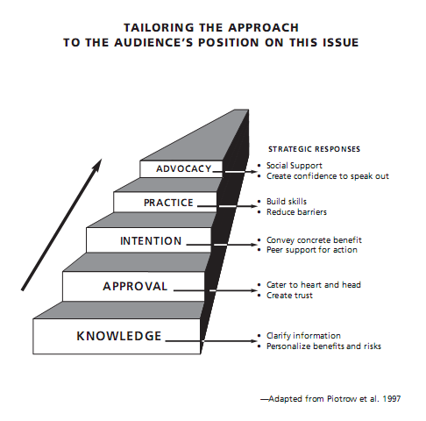
Robinson's solution is to identify seven steps to social change:
1. KNOWLEDGE - knowing there is a problem
2. DESIRE - imagining a different future
3. SKILLS - knowing what to do to achieve that future
4. OPTIMISM - confidence or belief in success
5. FACILITATION - resources and support infrastructure
6. STIMULATION - a compelling stimulus that promotes action
7. REINFORCEMENT - regular communications that reinforce the original message or messages
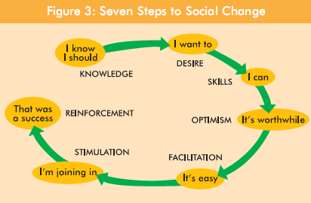
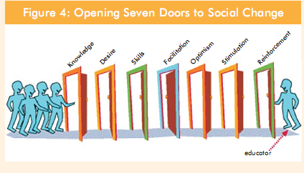

Activity: Community Approaches to Awareness- raising
Consider for a moment the challenges attendant on raising awareness about a particular issue in your community. Try to list up to five approaches to awareness-raising that you think should be included in a communication mix focused on your Community. Why are they significant and what resources would be required?
1. ______________________________
2. ______________________________
3. ______________________________
4. ______________________________
5. ______________________________
Planning an Awareness-Raising Campaign
(Message, Audience, Strategy and Timing) and consider now the following simple questions in relation to your campaign:
1. What is the central message or messages of the campaign?
2. What are the goals or objectives of the campaign - what will a successful campaign be seen to have achieved when it is complete?
3. Is government, civil society or community authority or endorsement required to run the campaign nationally and locally?
4. Who will comprise the target audience or audiences for this campaign?
5. What will be the overall reach of the campaign – realistically, how many people in the target audience or audiences will be exposed to the central message of the campaign?
6. What communication strategy will be most effective for reaching the intended target audience or audiences – to increase the reach of the message and enhance audience understanding?
7. How much information should be provided in support of the message? Our aim should be to inform and educate our audience, not overwhelm them with spurious facts and figures.
8. What level of public involvement will be necessary to ensure success?
9.What influence over the campaign is the target audience likely to want or need in return for their endorsement and/or involvement?
10.What time frame is involved - when will the campaign begin and end?
11.How will the stakeholders responsible for the planning and delivery of the campaign know that it has been a success how will the campaign be monitored and evaluated?

Activity: Awareness-Raising in Practice
Consider the following Fact Sheet extracted from the International Federation of Library Associations and Institutions' continuing "Campaign for the World's Libraries"19.
- What is the stated purpose of the campaign?
-------------------------------------------------------------------------------
- What is the central message or messages of the campaign?
-------------------------------------------------------------------------------
- What do you understand to be the goals or objectives of the campaign
what are the campaigners trying to achieve?
-------------------------------------------------------------------------------
- Who is identified as the target audience?
-------------------------------------------------------------------------------
- Has anyone authorized or endorsed the campaign?
-------------------------------------------------------------------------------
- What sort of audience reach is likely in this campaign?
------------------------------------------------------------------------------

Activity: Reinforcing the Message of Information
Literacy
Consider for a moment what physical props or sensory cues might be helpful in raising awareness about Information Literacy in your local community. An example might be to invite a respected local professional, perhaps a doctor or lawyer, to speak about the importance of finding and using up-to-date information in their daily work.
Try listing and describing five props or cues for raising awareness of
Information Literacy in your community:
1._________________________________________________________
2._________________________________________________________
3.________________________________________________________
4.________________________________________________________
5._________________________________________________________

Activity 2 : What are the different ways students would use to raise the information on these topics? Make sample message and poster for mention topics .

FOCAL POINTS FOR DISSEMINATION OF MESSAGES UNDER NRHM
- Safe drinking water
- Basic hygiene and sanitation
- Iodized salt
- Immunization
- Exclusive breast feeding
- Care of low-birth weight babies
- New born care
- Contraception
- Age at marriage
- Adolescent Health
- Importance of girl child
- Reproductive health/HIV/AIDS/STDs
- Focus on Non-communicable diseases.
- Focus on vector-borne diseases.

Hint:
Sample Messages
- Small family is happy family
- Buy one, get one free
- Small is beautiful
- No substitute for hard work
- Team works
- Together everyone achieves more
- Boond Boond Mein Vishwas

Exercise: analyse the effect of massage electric media on common use products Like nutrient supplement for children e.g. horlicks /bourmvita ,Common pills available for Diabetes. Arthritis, sexual vitality drugs
Hint:
Like in horlicks, the advertisement claims that for a definative period use of their substances will cause increass in height.
Regarding the subjects ,Check
- Are the subjects are Indian / europian.
- Socio economic status of family.
- Birth weight of the child.
- Disease status of the child

Are the results aptly applicable for indian child espicially of middle class family?
What are the possible substitutes can be used for weaning?
Are they equally effective with horlicks?
Do the ingredients analysis of horlicks?

Community Involvement and Communication
[Example on immunization]
Community role in supporting immunization
Attempt to involve the community, as much as possible, in each phase of the immunization program- planning, implementation and evaluation.
Planning: HWs should consult communities about service locations and timing to ensure a convenient service (e.g. shifting vaccination hours from mornings to afternoons in areas where mothers are busy in the fields in the morning).
Implementation: Communities can assist with:
- Arranging a clean outreach site (school, club, Panchayat Bhavan, etc.)
- publicizing immunization sessions (e.g. through announcements, messages from community volunteers, flags or banners at health centres or village sites that announce when immunization days are taking place)
- informing community members when the HW arrives at the session site
- registering patients, crowd-control, and making waiting areas more comfortable (by providing shade and organizing space and seating)
- health education -disseminating appropriate messages identifying and referring newborns and/or infants who have recently arrived in the community and sharing the list with HW to include in the Immunization register
- motivating fellow community members to use immunization services to bridge cultural or educational gaps between HWs and caregivers. This is particularly important where knowledge of and participation in
- preventive services is low
- transporting vaccines and HWs
- identifying dropouts and left-outs, making home visits when children are behind schedule, to explain immunization and to motivate caregivers
- communicating with local people and informing HWs about suspected Vaccine-Preventable Diseases (VPDs) and Adverse Events Following Immunization (AEFIs)
- monitoring the immunization program by reviewing the coverage data with the health team

Evaluation: Community leaders can contribute by responding to questions about the quality of services.

Steps for involving the community
Step 1: Identify the key stakeholders in the community and where they are located. These could be:
- Governmental departments and Staff (Health, ICDS, Education, District/ Block Administration, PRI)
- NGOs and local organizations (Nehru Yuva Kendra, National Service Scheme)
- Professional Associations (Indian Medical Association, Indian Association of Paediatrics)
- Community (Parents, Village Health and Sanitation Committee, caste and religious groups, SHGs)
- Private and traditional health practitioners
- Media
Step 2: Conduct a situation analysis
- Identify well performing and poor performing areas in terms of data on vaccination session attendance and local coverage levels
  - Assess through meetings, small group discussions or discussions with opinion leaders (See Appendix 7.1)
  - Community awareness and perceptions about immunization services
  - Perceived barriers to immunization (related to quality of immunization services and the Community knowledge, attitudes and practices)
  - Issues affecting physical access to services (location, frequency, schedule)
  - Access by special groups (minorities, migrants etc.)
- Explore the problems and possible reasons for left-outs and dropouts. Jointly seek possible solutions.
- Assess the current extent of community’s involvement with immunization services and discuss possible community support.

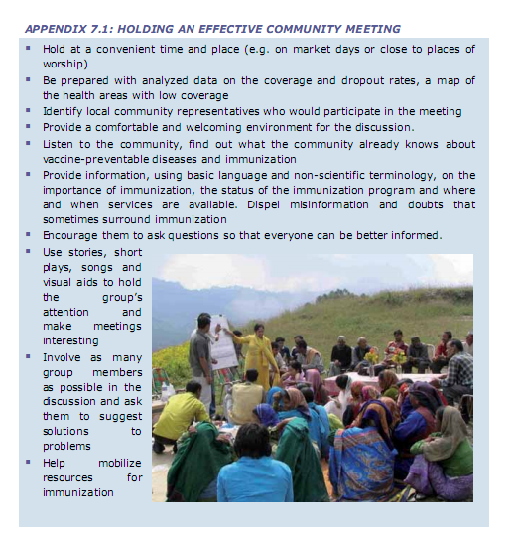

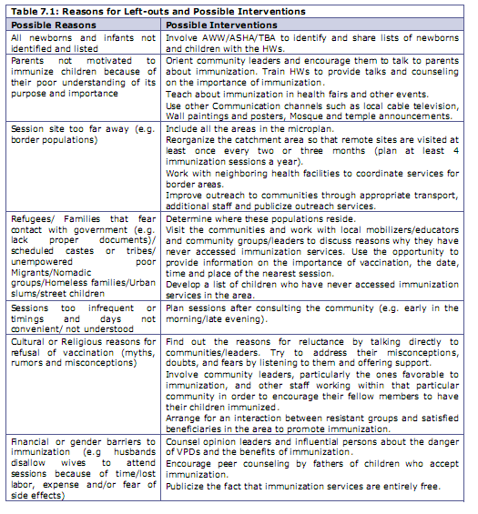

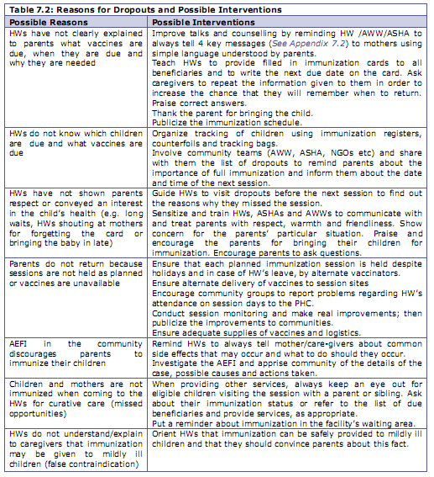

Step 3: Establish mechanisms for coordination
Establish a consultative mechanism at the block/PHC level or use existing forums such as the Rogi Kalyan Samitis to ensure regular coordination between departments and to enlist community support for immunization services.
- Involve representatives of the key stakeholder groups (Listed in Step 1)
- Inform the members well in advance and prepare a clear agenda for the meeting including:
  - State and district immunization goals
  - Current status of immunization in the district and block
  - Key challenges and areas requiring support
  - Possible roles of stakeholders
  - Preparing and implementing a communication plan

Step 4: Develop a communication plan
The plan should broadly address the following issues.
- The communication activities in response to specific problems in the immunization program
- The personnel and resources required
- Timeline for implementation
- Monitoring mechanisms.
Based on the prioritization of areas described in Table 9.4,
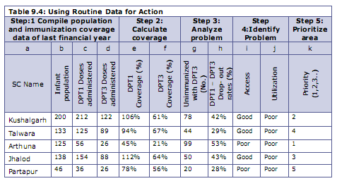

prepare a communication plan as outlined in Table 7.3.
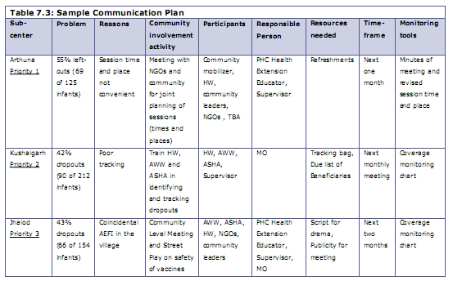
Channels and tools for communicating information on immunization
The Immunization Program uses many different communication methods to reach parents and other target audiences e.g. radio, television, folk media, community meetings, and interpersonal communication during sessions. At the PHC level, you can effectively use the channels and tools for involving and informing the community about immunization services. (See Table 7.4)
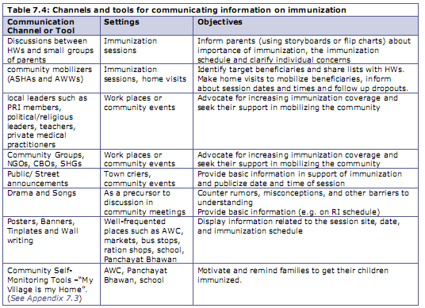

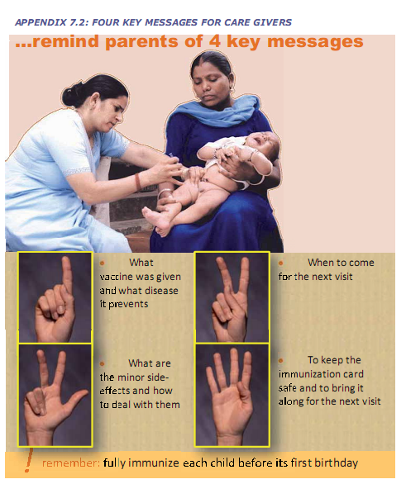

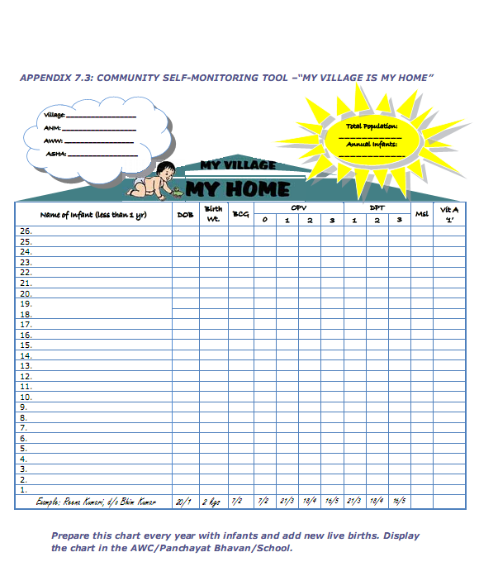

ACTIVITY –2
Exercise on immunization:
Learning Objectives
By the end of the session, participants will be able to:
- Identify the types of communities and stakeholders and how they can be involved in Immunization
- List the reasons for left outs, dropouts and fully immunized.
- List steps for involving the community and prepare a communication plan
- Describe the various communication channels

Session Overview
A. Type of communities and stakeholders and the community role in immunization
B. Reasons for left outs, dropouts and fully immunized
C. Steps for involving the community and Communication Plans
D. Channels of Communication

A. Types of Communities and Stakeholders and the community role in immunization
1. Read aloud the posted Learning Objectives
2. Ask participants what are the different types of communities and various stakeholders in the community. List these on a flipchart.
3. Now ask participants (community roles in supporting immunization). A facilitator reads aloud the section and another facilitator notes the key points on a flipchart.

B. Reasons for left outs, dropouts and fully immunized
1. On the black/whiteboard, explain the concepts of left-outs and dropouts.
2. Divide the participants into four groups.
3. Ask

Group 1 to move to the far corner of the room to represent that they are living in a remote hamlet without any sub-centre in their village. Outreach sessions are also rarely held in their village. Explain that their children are examples of one type of left out, i.e. they are hard to reach geographically and have difficult access to services. Request that they remain standing and ask them to briefly state some of the reasons why their children do not get vaccinated. Also ask them to suggest some possible solutions (e.g. have more regular outreach sessions, support the mobility of the health worker, etc.) and write their responses on a flip chart.

4. Now turn to Group 2 and explain that theirs is a large village which is easy to reach, but that they have many children that have never begun vaccination. They therefore represents the seconds kind of “left outs”. Ask them to state the reasons why their children do not go for vaccination (e.g., social inaccessibility as scheduled castes or tribes, un-empowered poor, migrants, border populations, mistrust of immunization by minority populations, etc.). Ask them to suggest some possible solutions (e.g. counselling by ASHAs /link workers, involvement of community leaders, better tracking, etc.) and write their responses on a flip chart.
5. Now explain to Group 3 that their children started the vaccination schedule but Have not completed it and no longer go to the session. Explain that their children are drop outs. Ask them to state why their children dropped out (e.g. lack of information on the vaccination schedule, vaccines not available on the day they go to the session, unkind treatment by the health worker, etc.) Ask them for some possible solutions (e.g. counselling by ASHAs/link workers, better tracking, capacity building of health worker etc) and write their responses on a flip chart.
6. Explain to Group 4 that children in their village are fully immunized. Ask them Why their children started and continue to go for vaccination. Write their responses on a flip chart. Possible factors for fully immunized children could be:
- Well informed about the value of immunization and schedule
- Husbands, mothers-in-law, other influentials are supportive
- No significant geographical or convenience barriers
- Have time available when services are offered
- Have child care for other children
- Available services are reliable and friendly
- Community leaders visit and encourage immunization
- Heard about many child deaths before the immunization program started
- Have not had or heard about bad experiences with immunization
- Health worker tracks all children
Do not ask the groups to reassemble.
C. Steps for involving the community and Communication Plans
- Reassemble the groups. With the aid of the Steps for involving the community (Poster 15), detail out the steps in involving the community.
- Explain in detail, the components of a Communication Plan. Ask participants to consult Table 7.3:. Discuss the usefulness of such a plan in the work places of the participants

D. Channels of Communication
1. Ask participants to brainstorm on the different channels of communication. List the responses on a flipchart. Prompt for any communication channels that have been missed.
2. Initiate a discussion on the relative effectiveness of the various communications Channels that have been listed. Emphasize on the effectiveness of inter-personal Communication and draw the attention of participants to the 4 key messages

ANNEXURE- 1
This exercise will help students to know
- common challenges
- critical factors influence communication complexity

Communication in Practice - "Pass-it-on"
In many parts of the world, children play games that involve passing messages from one child to the next. Wherever these games are played and whatever they are called, they serve as simple yet profound reminders of the difficulties associated with human Communication.

Try playing this game with stakeholders as an 'ice-breaker' activity before brainstorming an awareness-raising campaign. The rules are quite simple.

- Participants space themselves out so they can whisper to their immediate neighbours to the right, left, in front and behind but not hear anyone seated further away.
- The facilitator writes a short message - no more than one sentence - on a small piece of paper and shows it to the first participant at the front of the room. The facilitator keeps the paper.
- The first person whispers the message to their neighbour and so on around the room until it reaches the last participant at the back. This person is invited to share the message, as they heard it, with the group.
- Regardless of the outcome of the message (reasonably accurate or highly distorted), participants are invited to discuss their insights about the game. A common realisation is just how easily information can become distorted by poorly constructed and managed communication. In social settings, we might call this 'gossip'.

Discussion:
Consider the popular game for children known in various parts of the world as "Broken Telephone", "Whisper down the lane”, “Gossip" or "Pass-it-on" - see Appendix 1. The idea of this game is simply to pass or transmit a basic message - usually a simple phrase - from one player to another without it being overheard,usually by means of whispering. The fun of the game lies in the subtle alteration of the message as it is passes from the first player to the last via a number of intermediaries. As the online Wikipedia notes, "If the game has been 'successful', the final message will bear little or no resemblance to the original, due to the cumulative effect of mistakes along the line." The critical lesson for observers is just how easily information can be degraded and altered through repetitive and careless communication.

As the "Pass-it-on" game demonstrates therefore, communication is not an easy process.
What are some of the common challenges?
- Communication is omnipresent and inescapable - it’s everywhere! The challenge is to separate quality from quantity.
- Communication is irreversible - once something is said or published it cannot be taken back or undone. The challenge is to avoid or minimise opportunities for misunderstanding and misinterpretation.
- Communication is complicated and the degree of complexity is most often determined by factors or variables that we can anticipate and to some extent control. The challenge is to manage these variables through effective planning, implementation and monitoring.

Three critical factors influence communication complexity and thus should be managed:
- The channel or medium used
- The personal experiences and opinions of the communicators(speaker and listener, writer and reader)
- Environmental factors that often have little or nothing to dowith the message being communicated

Common environmental factors include:
  - The physical space in which the communication is occurring -for example, if a public meeting is being held to share information, is the meeting room sufficiently large to accommodate everyone in relative comfort? The effectiveness of communication may be diminished if people feel crowded, they cannot hear the speaker properly, or the room is too hot or too cold.
  - External distractions that cause the message to be missed or, worse still, misunderstood
  - The credibility of the communicator - can I believe this person?
  - The listener or reader's level of education and background knowledge of the topic
  - The design of the message - is it appropriate to the audience?

ANNEXURE- 2
POSTER TIPS
How does a poster communicate?
A poster usually suggests action. It tells you to act NOW, unlike charts that usually
require a person to explain them. A good poster is self explanatory - it speaks for itself.
Posters make people STOP, READ and REMEMBER.

Poster Rules - There are three main rules when developing a poster:

1) Readable - All letters should be well drawn and all words spelled correctly

2) Simple - Each poster should contain only one idea. This one idea should be expressed by one drawing and as few words as possible. Plan before you start - choose the drawing first then pick the least number of words needed to get your idea across.

3) Well Designed - The drawing and the words should be put together in such a pattern that both will be pleasing to the person who looks at the poster.

Hints for Planning your poster -
There are several elements to consider when making a poster:
- Make your poster say something.
- Consider size requirements. (If the poster is to be in a contest see rules for exact size.)
- Carry one idea- simplicity gets attention.
- Who will be your audience?
- What do you want your audience to know or do?
- What materials or tools will you use (crayons, poster paints, watercolours, paste, photographs, paper, computer etc.)?

There Are Three Elements You Want to Be Sure You Consider for Your Poster.

- Information - Posters are a colourful way to arouse interest and catch the attention of a person long enough for them to get a brief important message. The message must be short so that the lettering can be bold and large and seen at a distance. The idea of a poster is to “telegraph” a short message as fast as you can and one that can be read at a distance.
When developing a theme does the poster attract attention, focus interest on one idea or motivate the viewer to take action? Is the message brief and direct? Is the poster limited to one idea and readable at a glance?

2) Art Design - Tell one story per poster. Use generous blank white space. One third of all the space on the poster should be blank. This emphasizes your message. Several methods can be used for emphasis: change of colour, change of letter style and size, use of all capitals, or all lower case lettering, underlining.....CAUTIONS.....do not overdo! Avoid dead centre as the major point of interest.
Informal arrangement is more interesting than formal balance. When the design looks the same on the right side as it does on the left, that’s formal balance. Balance gives a design stability. You can have asymmetrical balance, which is a variation on either side of the centre or bi-symmetrical design where the balance is the same on both sides.

Plan your lettering! Be neat and consistent. Lower case letters are easier to read than capitals. Fancy lettering is harder to read. Lightly draw pencil guidelines and remember to erase them. Poor lettering can spoil a poster. (Posters 14 x 22, should have letters from ¾ to 1 ¾ inches high) Is ratio of letters height to width (usually 5 to 3) adequate? Are letters well spaced to be able to read? Space the words to use the entire poster. If there is a lot of lettering, it should be grouped together to form your message. Check to be sure your words can be read from 10–15 feet. Use colours which are effective. There are 3 ways to make your colours visible at a distance. One is size! The larger the design element, the farther it can be seen. The second is the strength of the colours you use. Yellow, orange, red can be seen at the greatest distance. The third way is contrast; dark items against alight background or light objects against a dark background. Of course, black on white or white on black provides the greatest contrast. Do not use too many colours. Use a combination of colours that are closely related. Two colours and a neutral provide for one of the two colours to predominate and the other colours to serve as accents.

REMEMBER...Visuals must be visible. Use the following table to choose letter size and thickness, colours of letters and background.

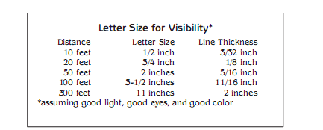

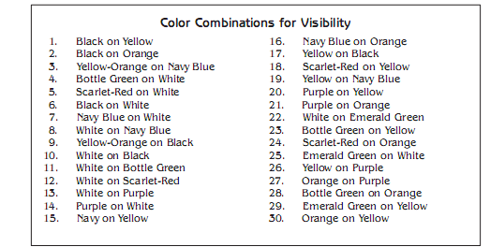

3) Construction - Needed equipment and tools
What materials are you going to use to develop your poster? Poster paints, crayons, pencil crayons, markers, (wide and thin), water colors, acrylics, ink, charcoals, oils, collage or computer generated? Poster Board - use a full size if possible.

Tools you may need include a ruler, gum erasers and rubber cement.

When doing a poster, plan enough time to make your poster, keep it simple and always do a draft on paper before putting onto the finished piece so you can check for correct spelling, placement and layout. One of the worst things that could happen is to find out after it is completed; you misspelled one word or miscalculated some of the measurements. Be sure your hands are clean, you have plenty of work space and think CREATIVELY in communicating your message.

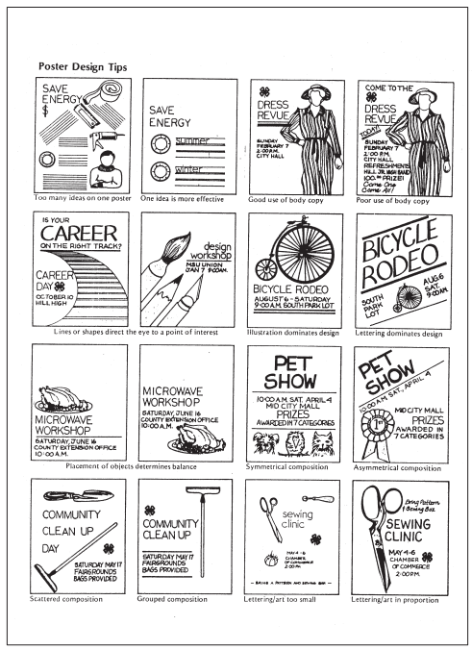

Source: Poster Tipsby Lauren Bressett, Debbie Cheever, Lisa Townson, Penny Turner UNH Cooperative Extension, 4-H Life Skills Work Tea website: ceinfo.unh.eduUNH Cooperative Extension is an equal opportunity educator and employer,UNH, U.S. Dept. of Agriculture and NH counties cooperating.



Example in poster making- Define your message: consider the alternatives

Do this ...  Be bold and be explicit! | ... not this  Hedge wherever you can.
• If you have an interesting result, then state it explicitly in the title: Water Temperature Affects Flounder Growth Rates | • Make the title as non-committal (and boring) as possible: The Effect Water Temperature on Flounder Growth Rates
• Make the strongest statements your data will support. Why soft-peddle exciting findings? "Substance X is essential to apoptosis in Y cells." | • Avoid committing yourself to any strong statement: "Antibody to X abolishes the response." Add qualifying words in abundance, such as: probably, perhaps, may, might.
• Interpret your findings in the conclusion - what do they mean?? "Greenways must be wider to support forest interior birds." (Of course, your results must support such a statement.) | • In the conclusion section, instead of interpreting your data, merely repeat the results - then say further study is required. "The effect of greenway width on forest interior birds needs further study." Since virtually everything needs further study, you can't be faulted.

Source: Creating Effective Poster Presentations :: Define Your Message , http://www.ncsu.edu/project/posters/NewSite/DefineMessage.html#Note0

ANNEXURE- 3
Guide for Conducting Community Leader Interviews
Introduction
Community leader interviews are a very effective technique for learning about an underserved o non-user community. The technique is personal and informative and begins the process of building trust that is essential for reaching the target community.
Community Leader Interview Process
The major steps in conducting community leaders interviews are:
- Identify community leaders (see Guidelines below and Community Resources list)
- Set up interviews (see Sample Process for Community Leader Interview)
- Conduct interviews (see Sample Community Leader Interview)
- Analyze/summarize information (see Guidelines below)
- Set up follow-up interviews (see Guidelines below)
Guidelines for conducting each step of the process are attached.
Goals of the Community Leader Interviews
1. To gather information about the needs of the target community.
2. To begin building relationships with leaders within the target community.
3. To identify potential community partners and collaborators to help you improve services to the target community.

Guidelines for Conducting Community Leader Interviews

Identifying Community Leaders
1. Use the Community Resources list to help you begin identifying potential community agencies and groups to contact. Your goal is to identify community leaders that have knowledge of or experience working with your target community.
2. The leaders you interview do not necessarily have to be members of the target community themselves. They must, however, be knowledgeable about the needs and issues of the community. They might have gained their expertise by working for an agency that serves the community or they may be community activists with a broad knowledge of community problems and issues.
3. Not all types of organizations on the Community Resource list may be represented in your community. You may already be familiar with some community leaders through the newspaper or other media coverage. Start with what and whom you know. Talk to other people in the library, your church, friends, neighbors, etc. who may have a personal connection with a potential interviewee. It helps to be able to say that someone they know referred you to them.
4. Make a list of a minimum of 5 community leaders to interview. These are busy people and your schedules and deadlines may not coincide.

Setting up the Interview
1. The sample process provided is intended to be a checklist for you rather than a script. You are starting a personal relationship so be sure you are as comfortable and informal as possible. Practice what you want to say before you make the first call.
2. At the end of the interview be sure to ask them for additional names of people you should contact. By now the community leader knows you and what you are trying to accomplish. They can be invaluable in expanding your list of contacts. Be sure to always mention their name if you follow-up on their referral.
Conducting the Interview
1. Even though the community leader may offer to come to the library or your office, make it a point to conduct your interviews out in the community. You want to see them in their milieu and you want others in the community to start seeing you out in the community. Face-to-face interviews are preferable to phone interviews.
2. The interview questions are intended as a guide. Be flexible and alert. The interview doesn’t usually follow the simple 1-7 pattern of questions. Often the leader will answer several of your questions at once. If so, when you get to a question that the leader has already addressed simply summarize what they said and ask if they have additional thoughts on the question.
3. Practice saying the questions out loud ahead of time. Rephrase them so that you feel comfortable asking them.
4. Start by building rapport on a personal basis. The session should be informal and relaxing. Find out about the person, the organization and the background about key services and projects they provide before you start the interview questions.
5. If someone they know has referred you to them be sure to mention this. Strive to make a personal connection immediately.
6. The focus of the interview questions is to identify community needs and issues. The purpose of the interviews is to get to know the community from an insider’s perspective. The focus is not to get the community leader’s perspective on what the library should be doing to serve the community. That will come later. At the interview your role is to acknowledge and tap into the expertise of the community leader.
7. Take notes but do not use a tape recorder. Feel free to take the time to write good notes. Ask the interviewee to repeat if you missed something or rephrase what you thought you heard. The interviewee wants to help you get it right.
8. If at all possible, end the interview by letting them know when you will be back in touch. Let them know that you will send them a copy of your findings, results, etc.

Summarizing the Interview
1. Review your notes immediately after the interview. Sit in your car or outside their office and be sure you can read what you wrote.
2. Transcribe and summarize your notes as soon as possible. Make a list of the needs and issues identified; highlight those that are repeated or mentioned more than once.

Set Up Follow up Interview (within first three months following initial interview)
1. The community leader interview process is the start of a relationship. As a minimum, plan to meet with the leader at least three times:
- The first meeting should be to conduct the interview and begin the relationship.
- The second meeting should be a personal follow-up with the results/findings of your interviews and to get their input on your preliminary action plan.
- The third meeting should be to get their help in marketing your activities, services to begin implementation of your action plan

